Landing Page changes

Invest now CTA should be small and text should come in one line

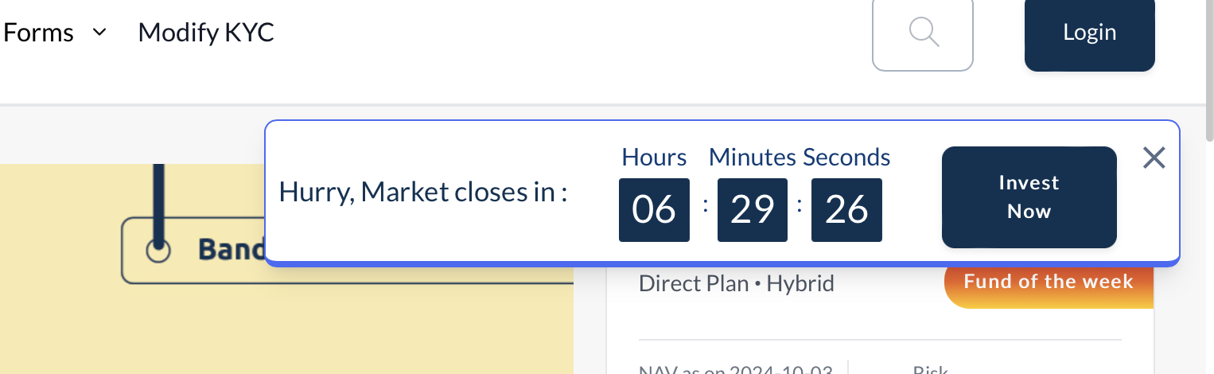

Milind – This component is disabled as requested by Aditya & Abhishek.

Scheme name Font size : 16px

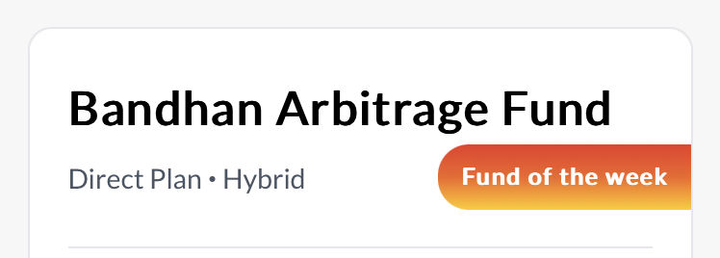  
Milind – This size is set to 24 as confirmed with Abhishek.

* Border radius is not same like other div,
* Font weight should be reduced  
  

Reduce character of subheading



* Font size and letter space should be reduced of Scheme name in fund card,
* Separation between NAV and risk is not proper
* Selection of year chip changes the height of container
* Container behind the fund card is extra
* Remove CTA shadow
* After changing from direct to regular toggle, whole layout is getting disturb in loading view
* Hover effect is missing

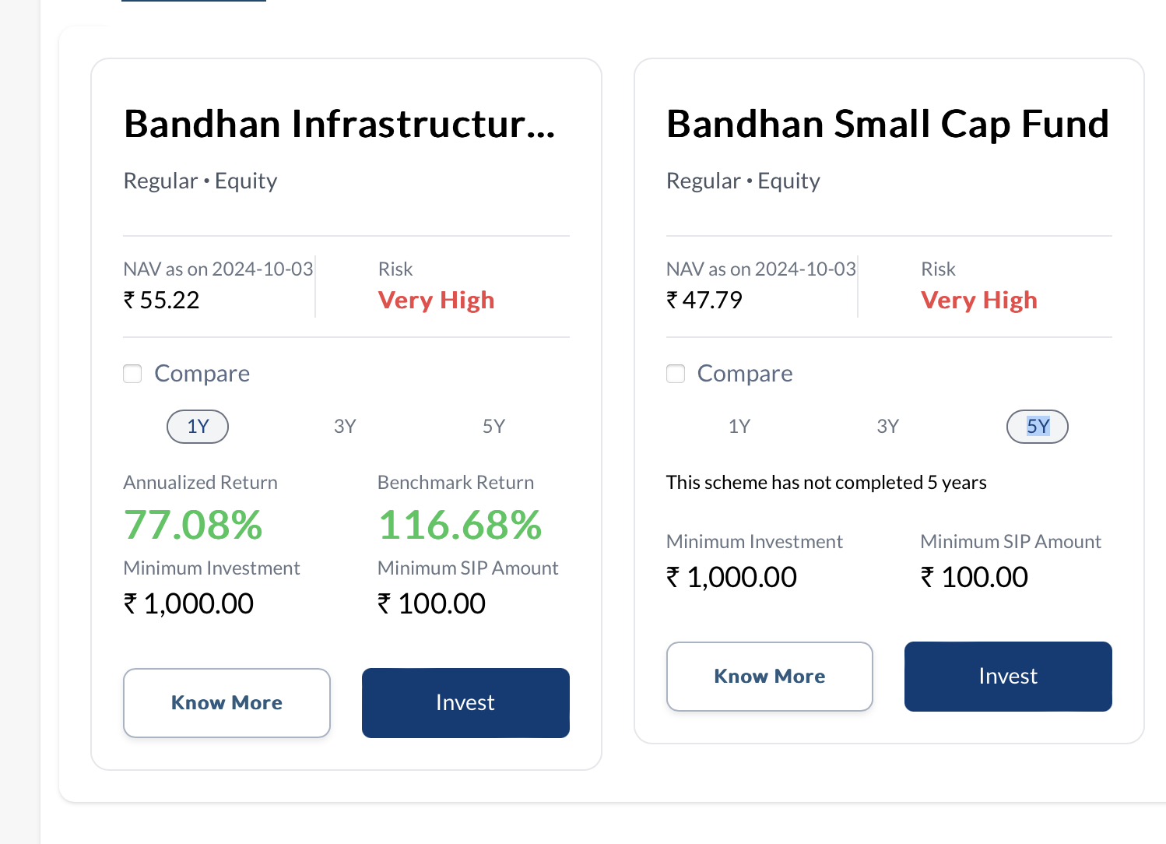

* Font weight hierarchy is not properly maintained
* Letter spacing of subheading should be reduced
* Space between input value and field line is not proper

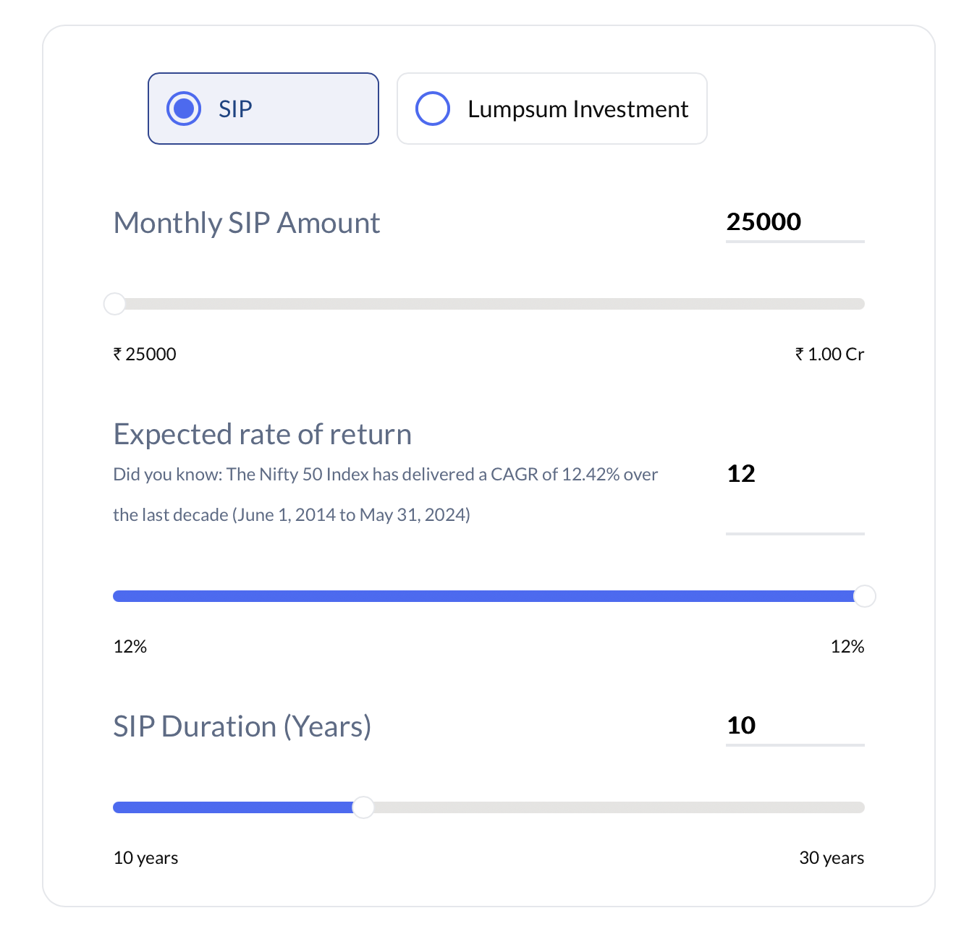

* Line below the selected Tab is not present



- Cards shape is not properly maintained



While hovering it changes the layout



Fund list

* Search icon is not properly alligned ----- DONE
* The container behind the fund cards should not be present --- DONE
* The fund type description is not proper--- DONE
* The date of NAV in fund card ---DONE
* Page is getting fluctuate while toggling direct to regular ----DONE
* Color the risk factor---------- DONE

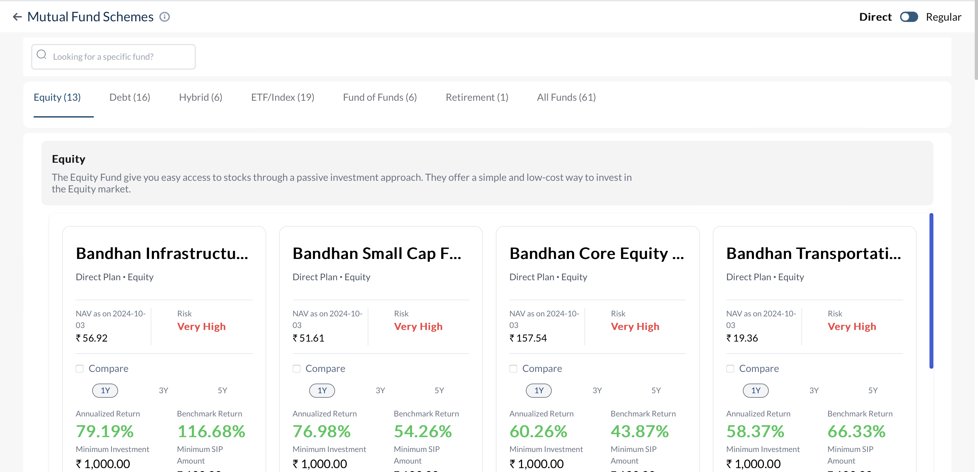

Font size of NAV value and minimum investment values should be similiar ----- DONE

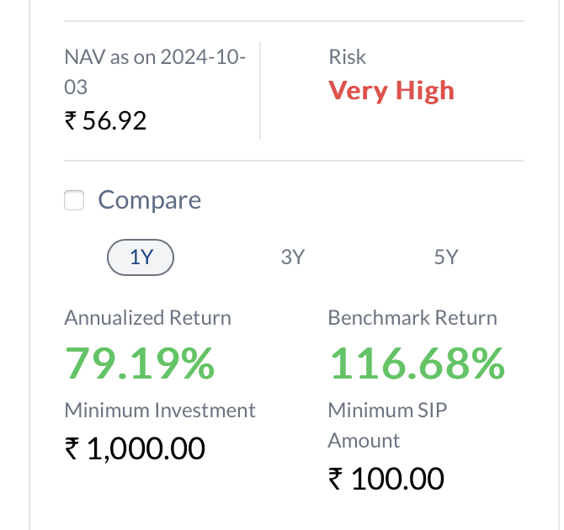

* Hover state of fund card is missing in development
* Filter is missing REMOVED

- Font size is different for Both CTA (Know more and Invest)

- Font size and weight should be maintained as per design

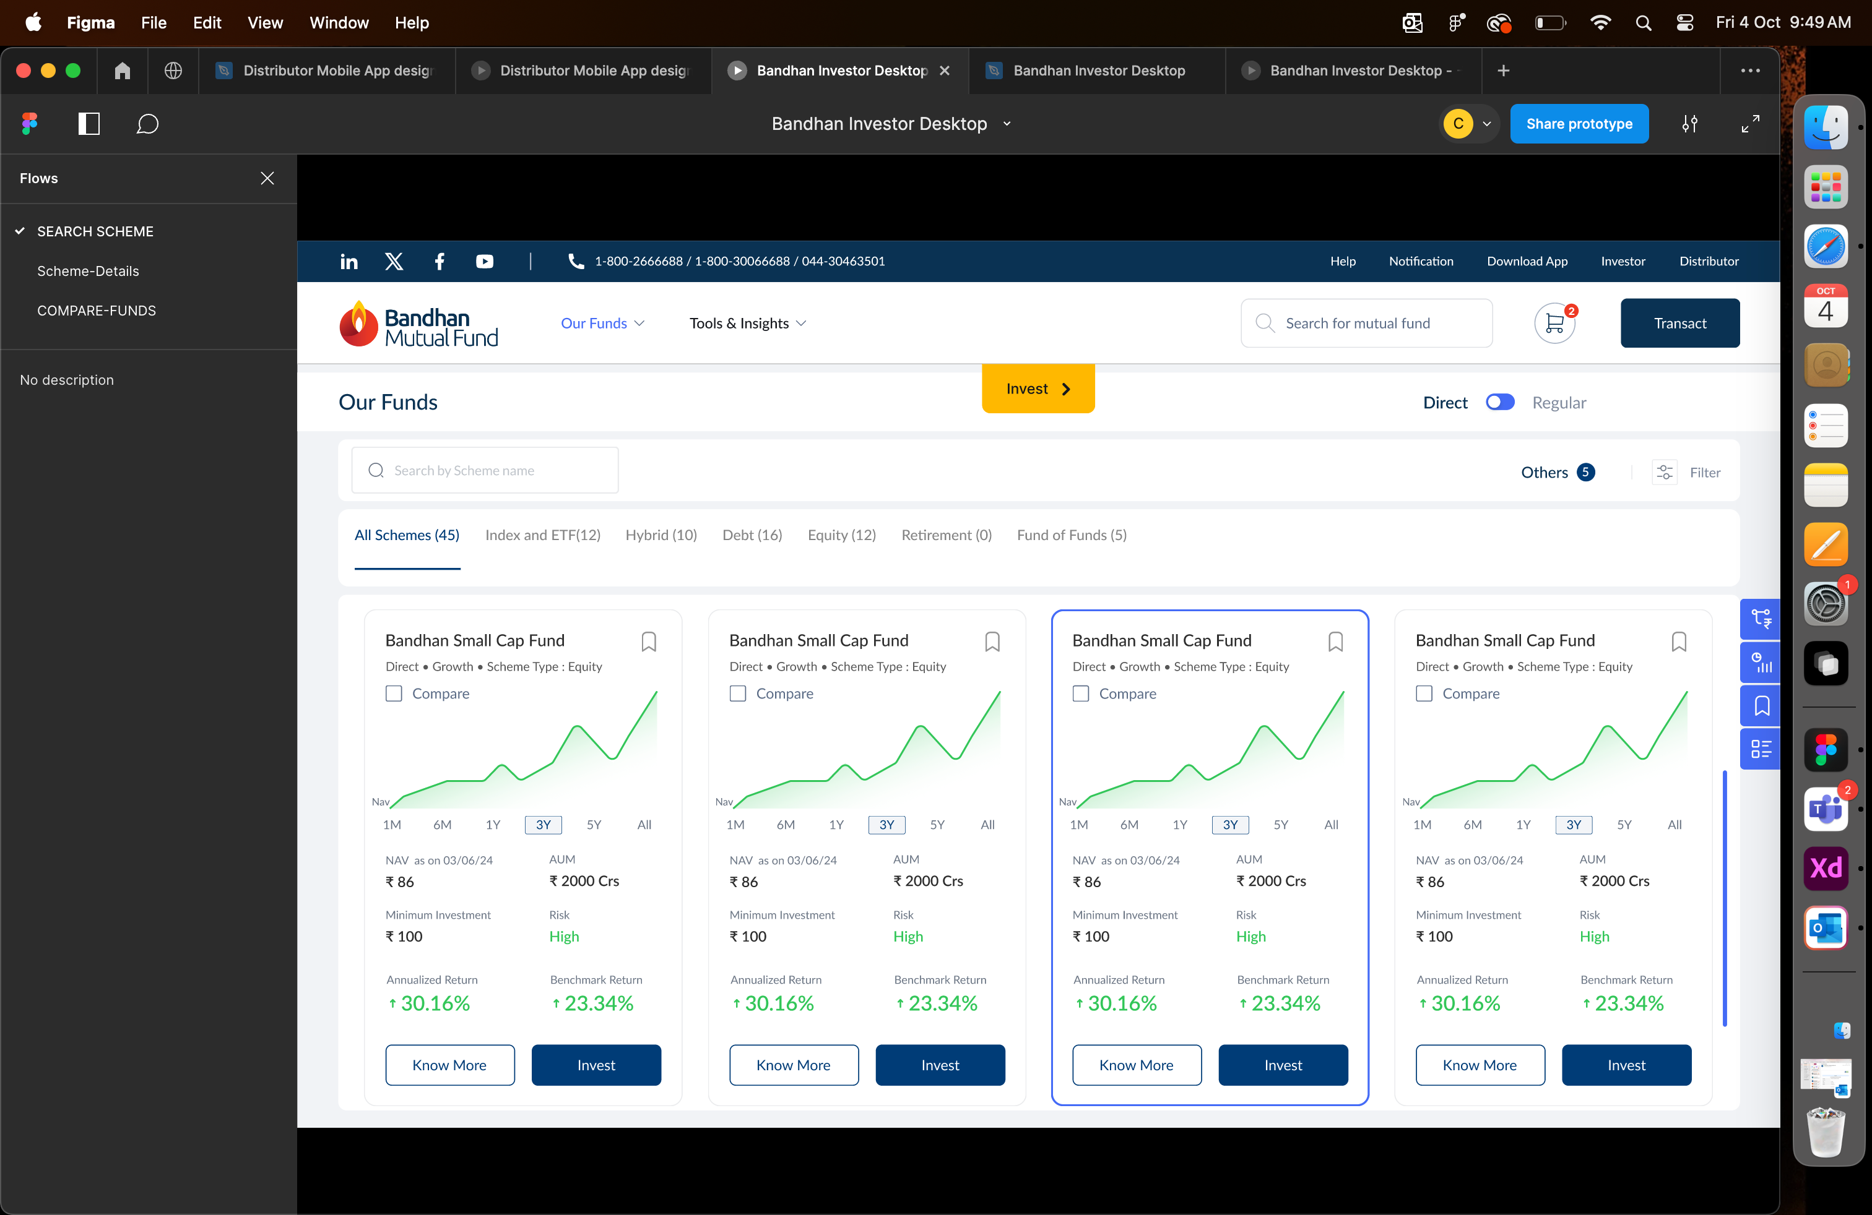

* Gradient is missing
* Container of fund cards is not maintained properly

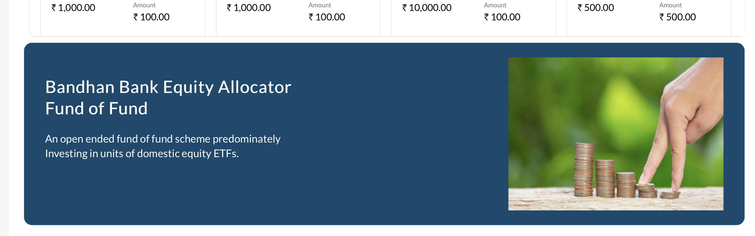

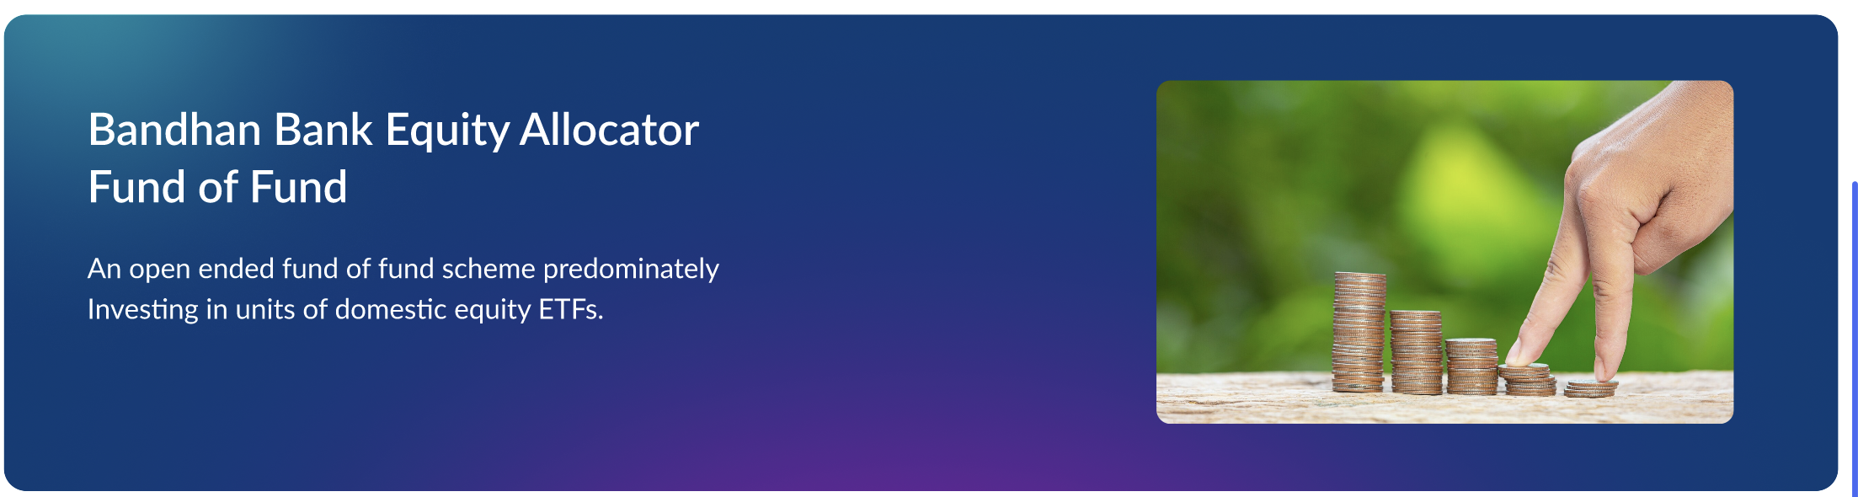

* Font size and weight should be maintained as per design

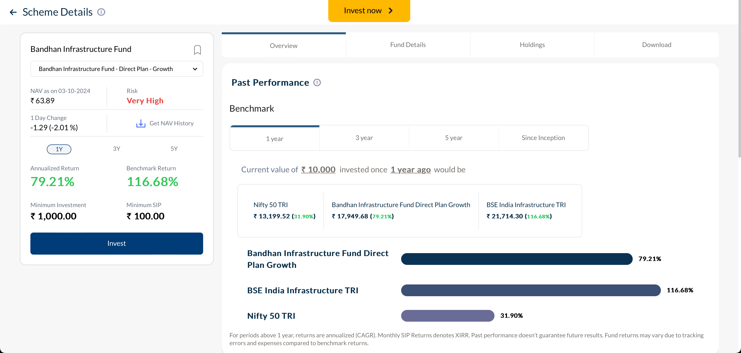

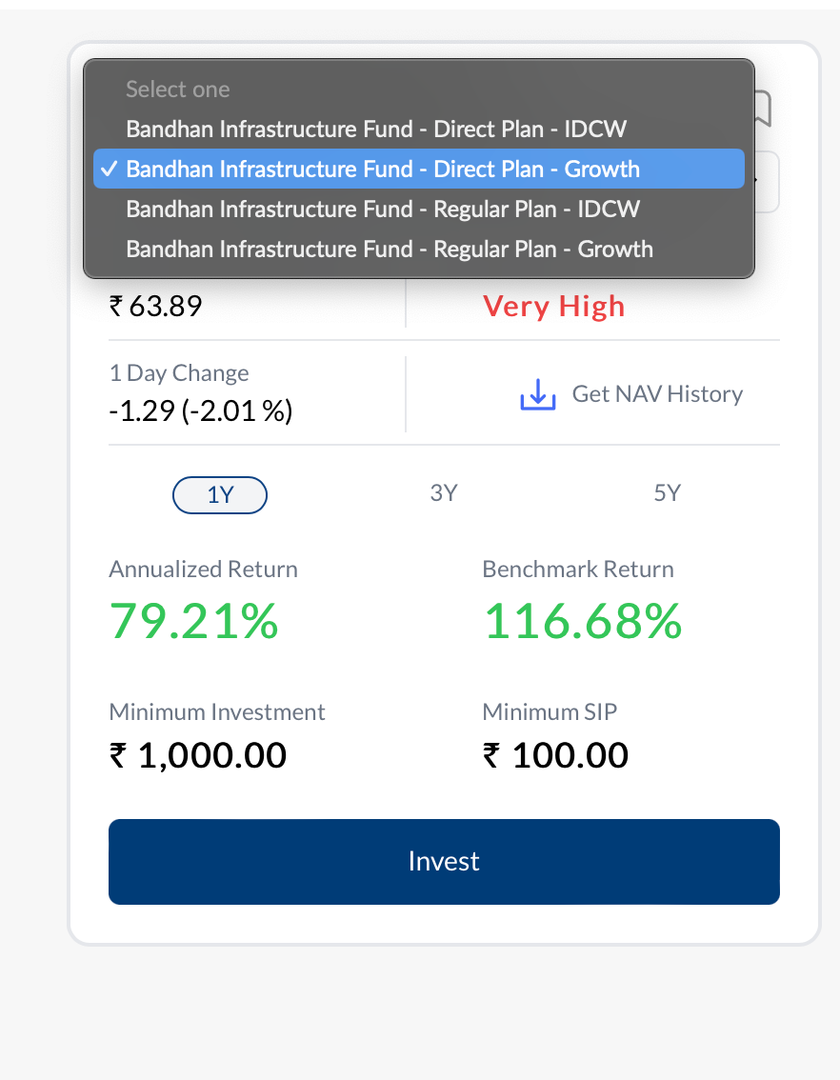

* Horizontal scroll should not be present---- Done
* Scheme name should be properly aligned --- DONE

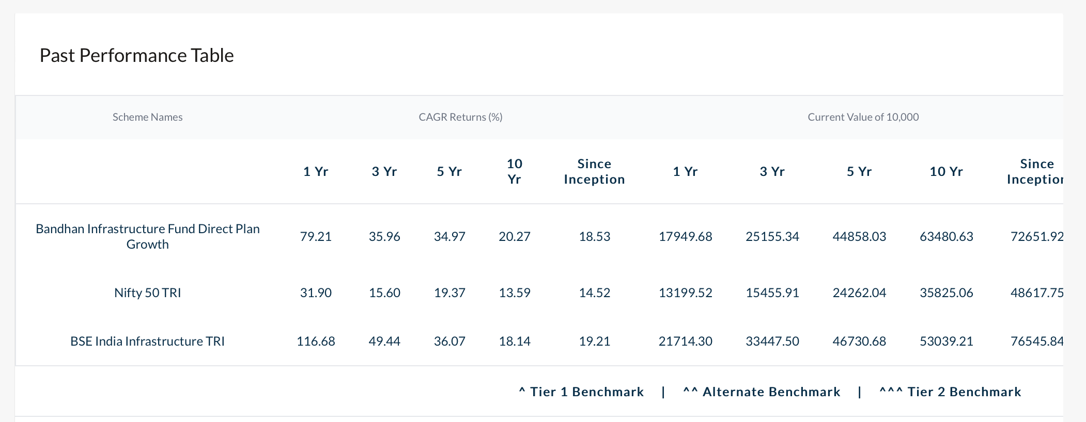

- Text alignment not proper

* Minimum investment is not properly aligned --- DONE
* Add to cart CTA is missing REMOVED
* Date format should be changed ( 1 Oct, 2024) DONE

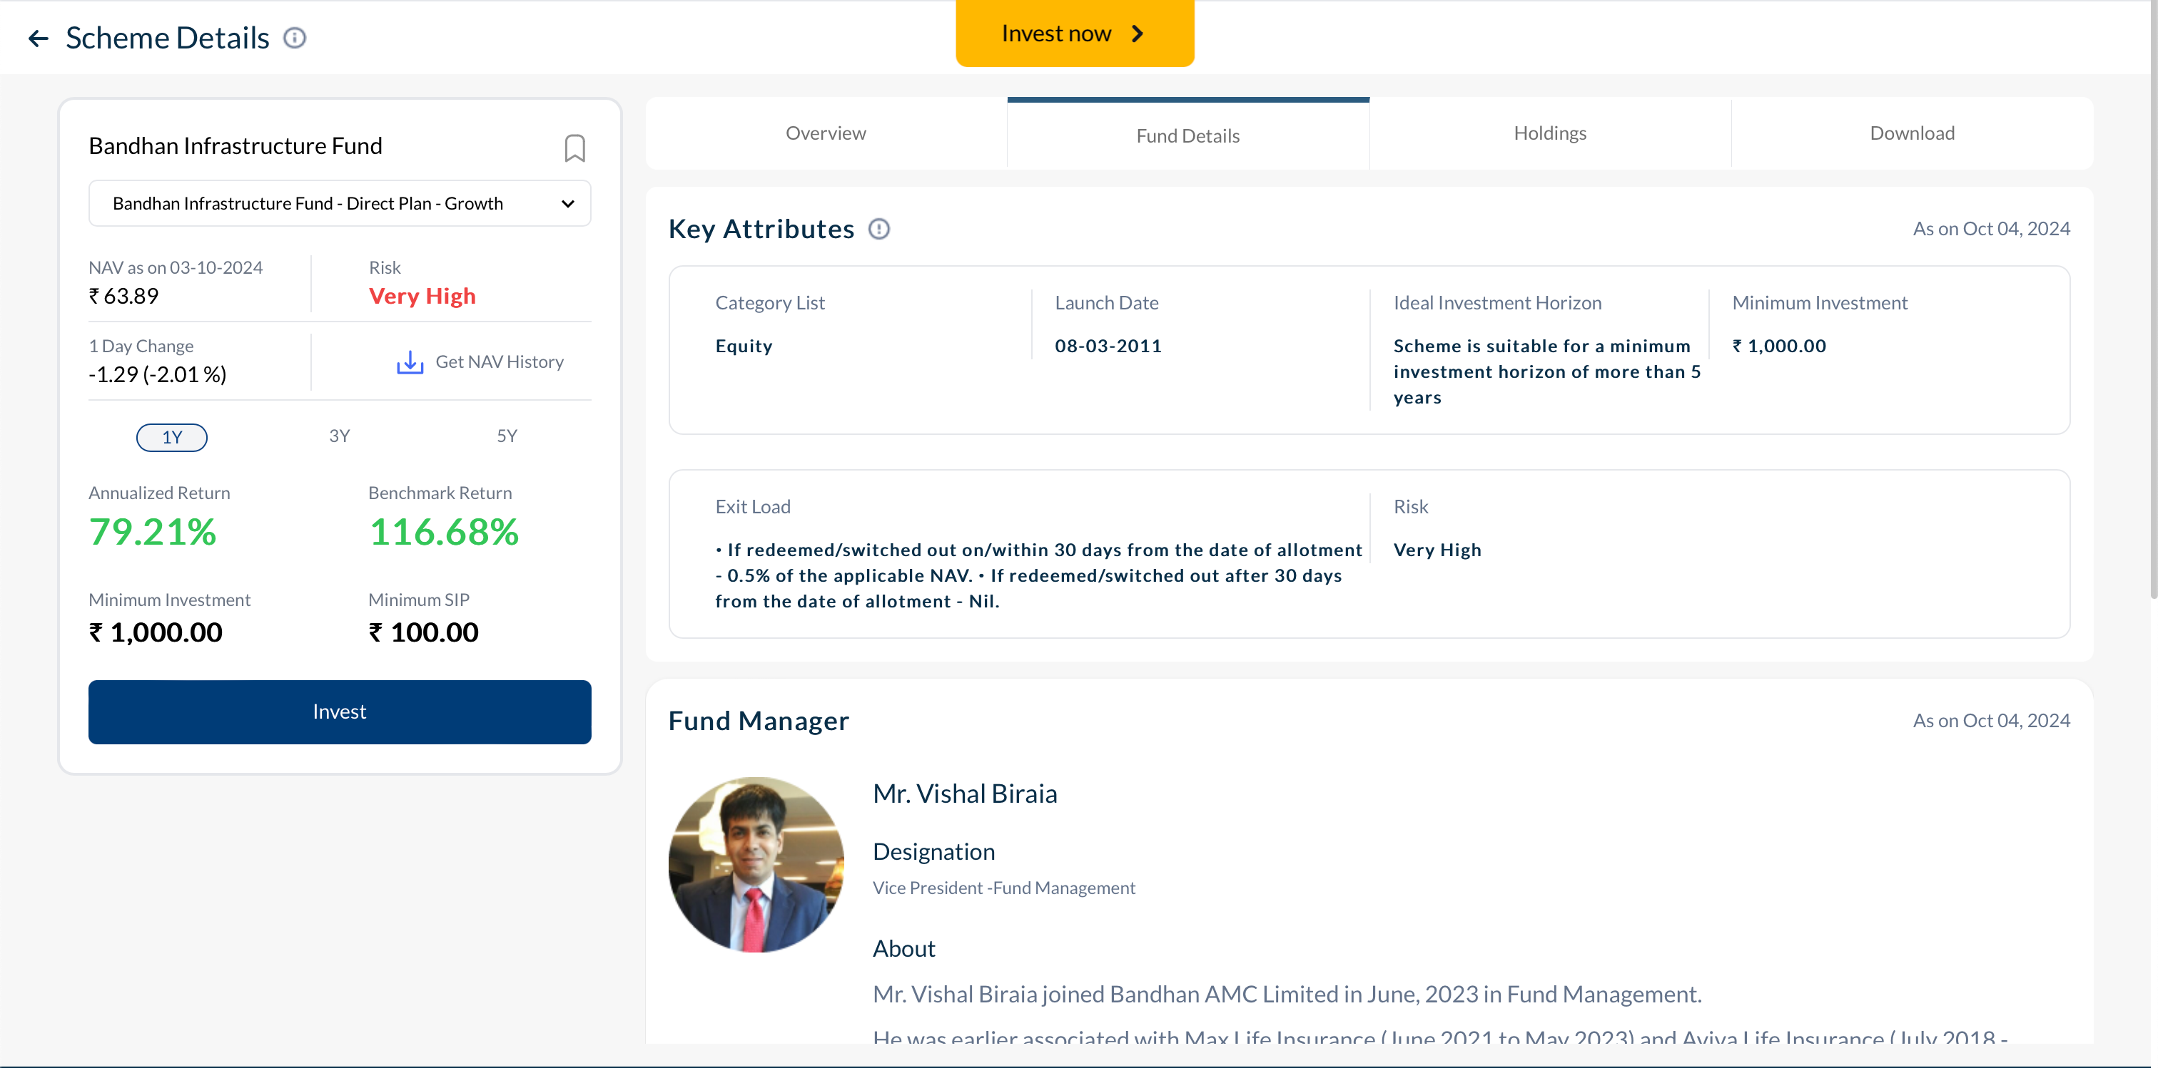

Spelling of Riskometer is not right

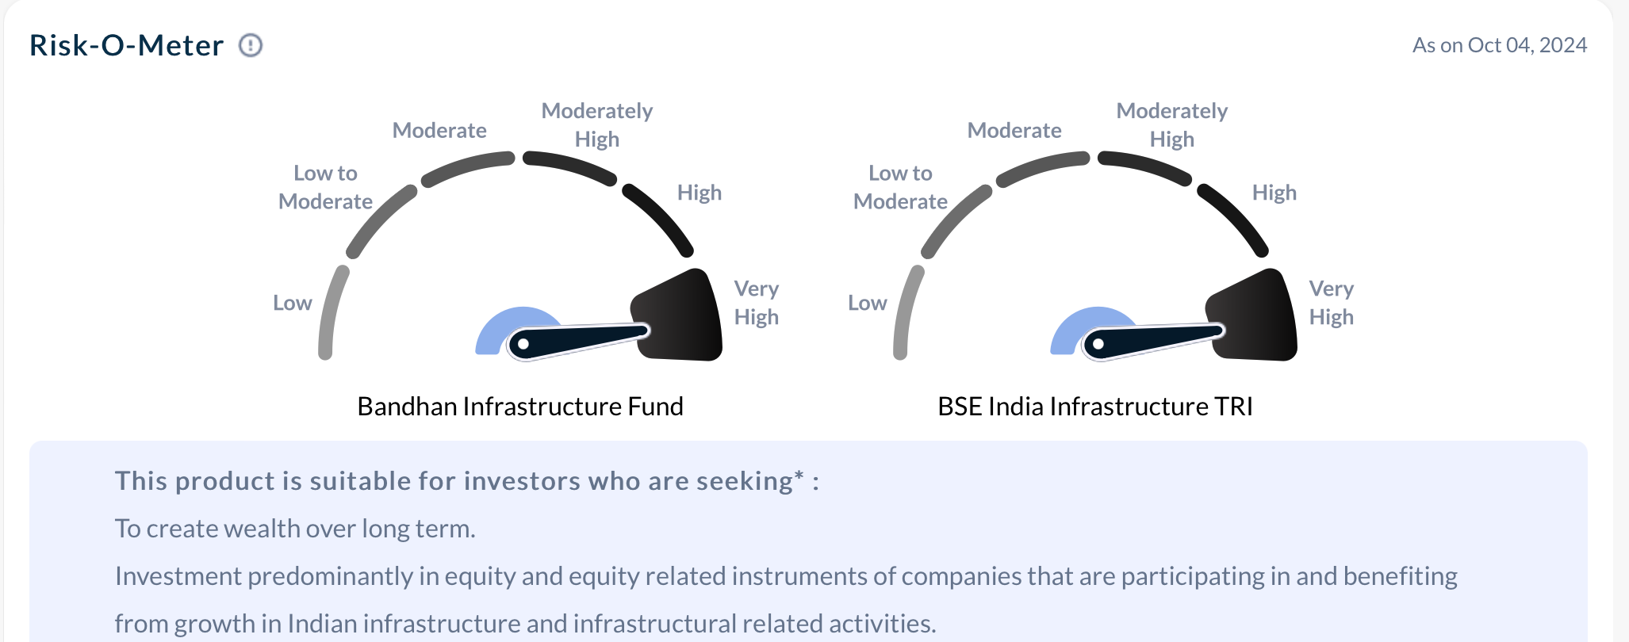

* Right side of container should be static , not scrollable -- DONE
* Left side should be scrollable DONE

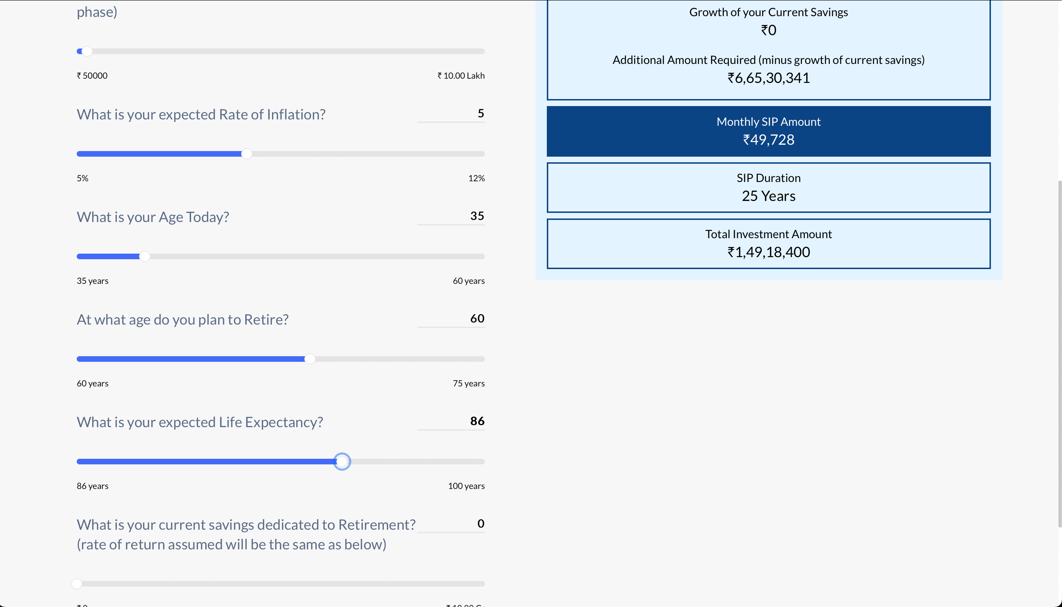

- Money wise podcast should be changed to Podcast ---- NOT Possible

* Videos would not be there ---- NOT POSSIBEL

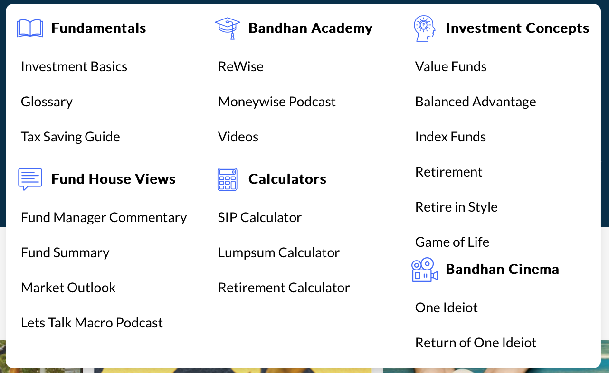

* There should be no View more CTA, all videos should be display here DONE

- Search field is not aligned ----DONE

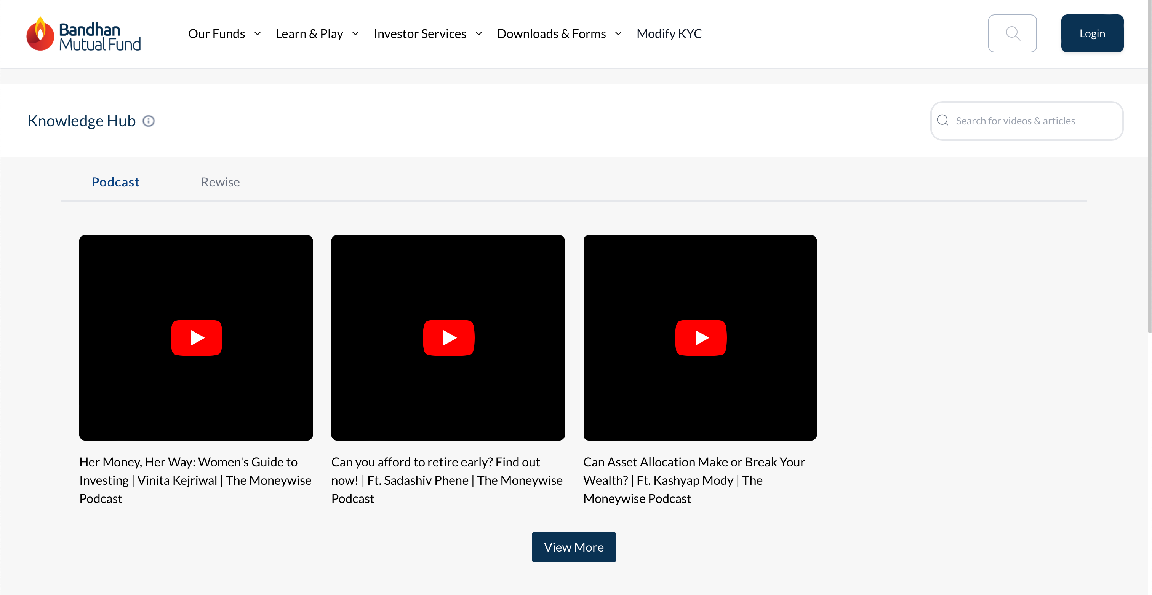

Alignment should be proper of cards

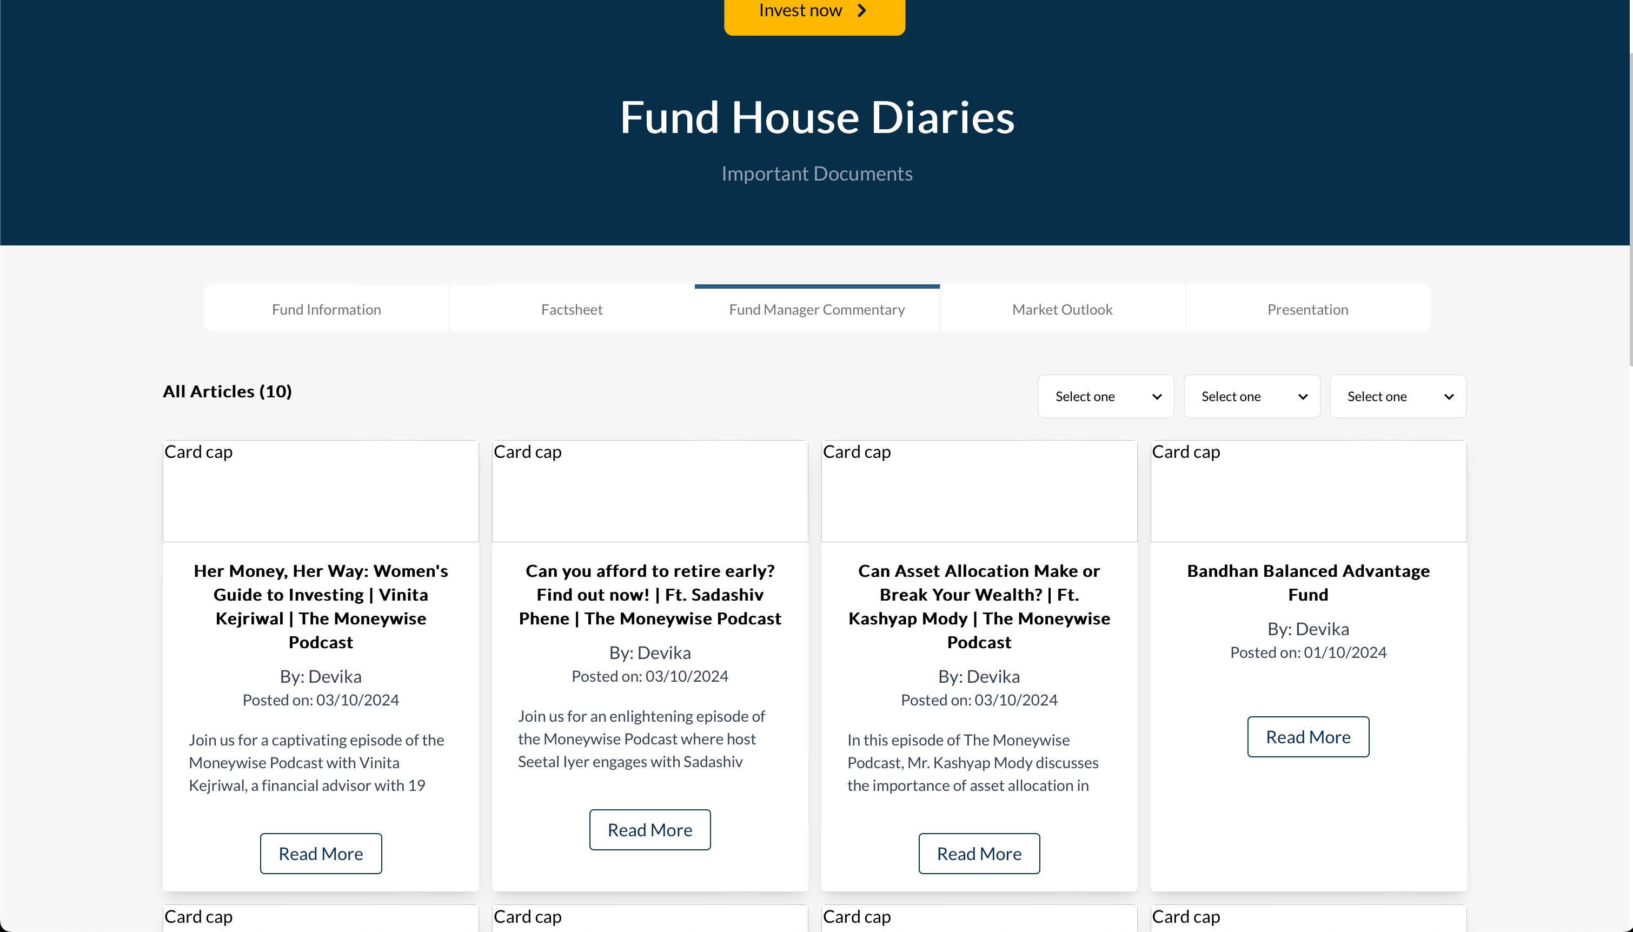

Stroke color is different for different field ---DONE

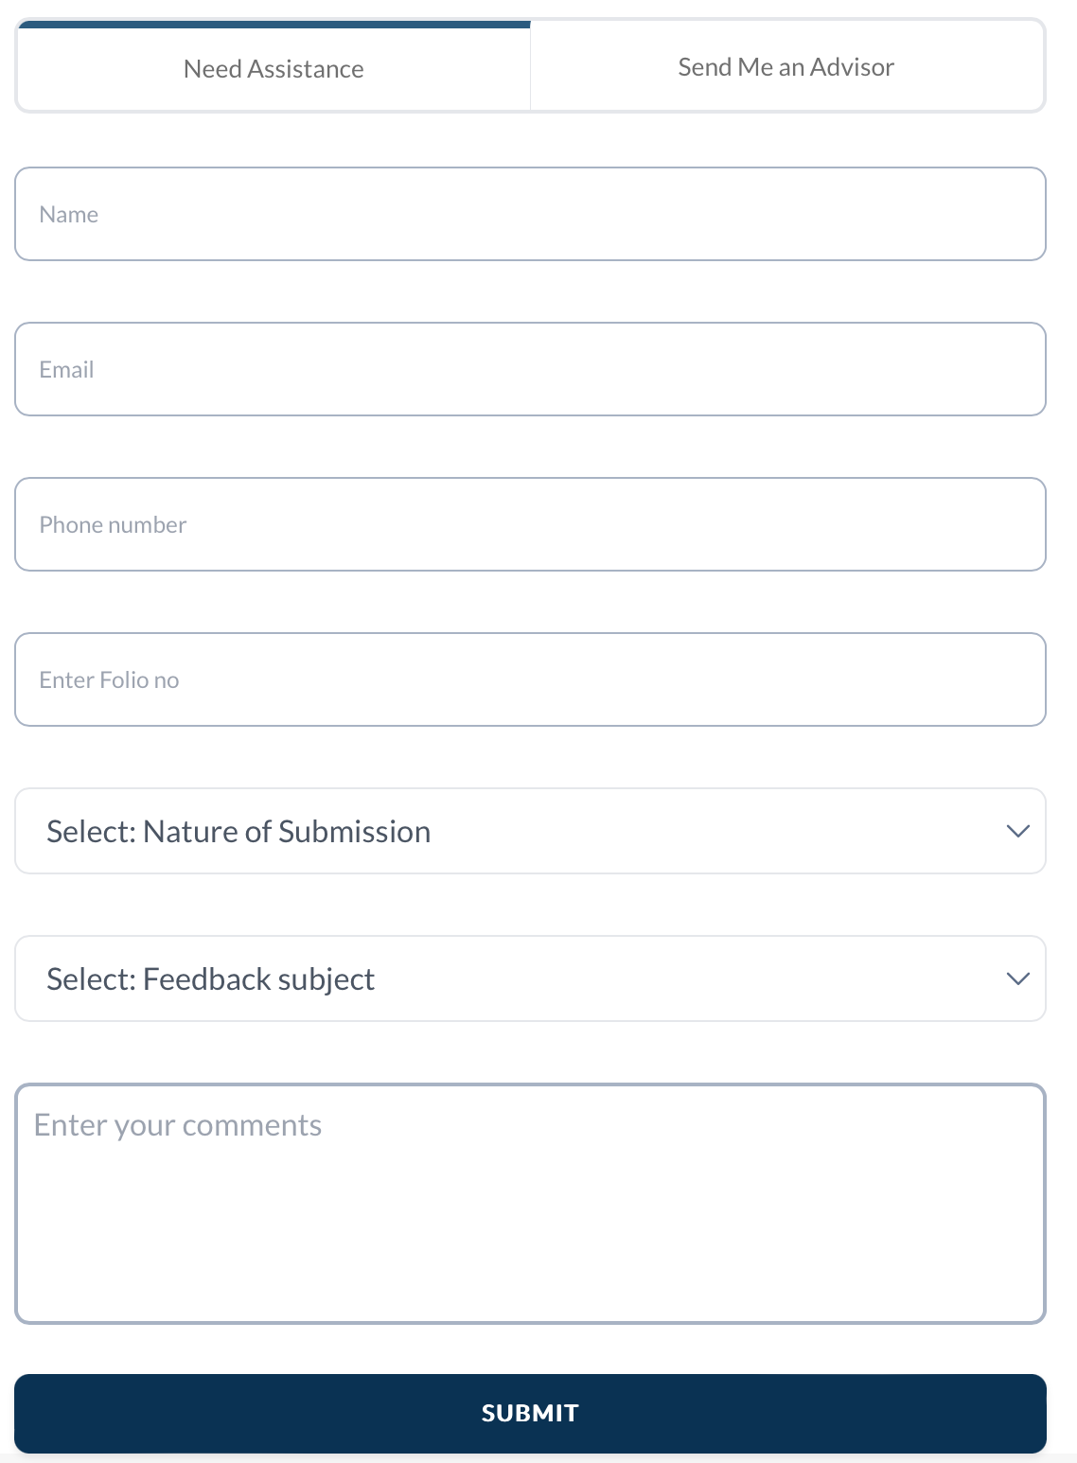

Font and color should be same of services and FAQs ------Done

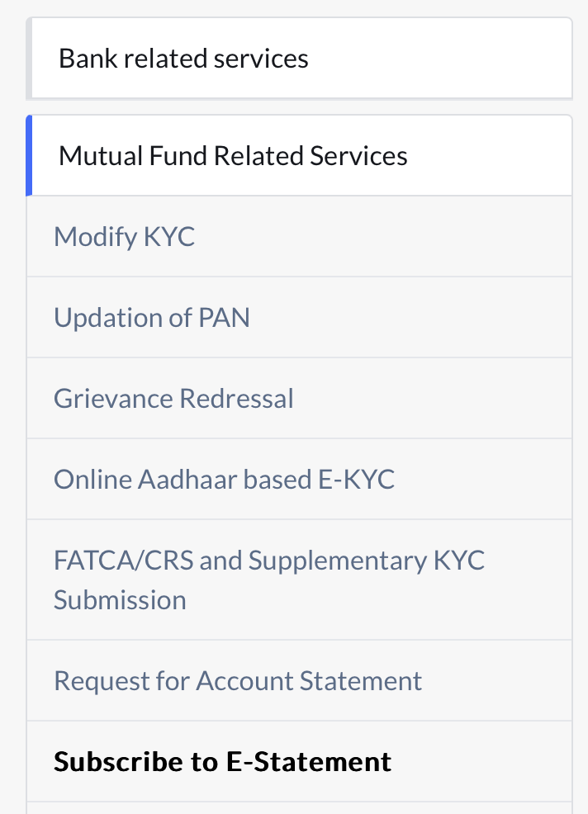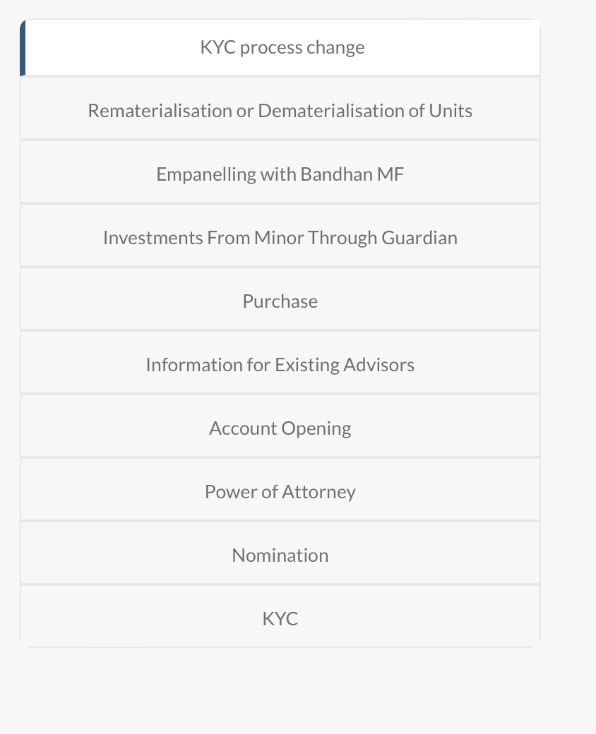

Create new folio

* Error is not showing proper for every mandatory field
* Border radius and border of every field is different

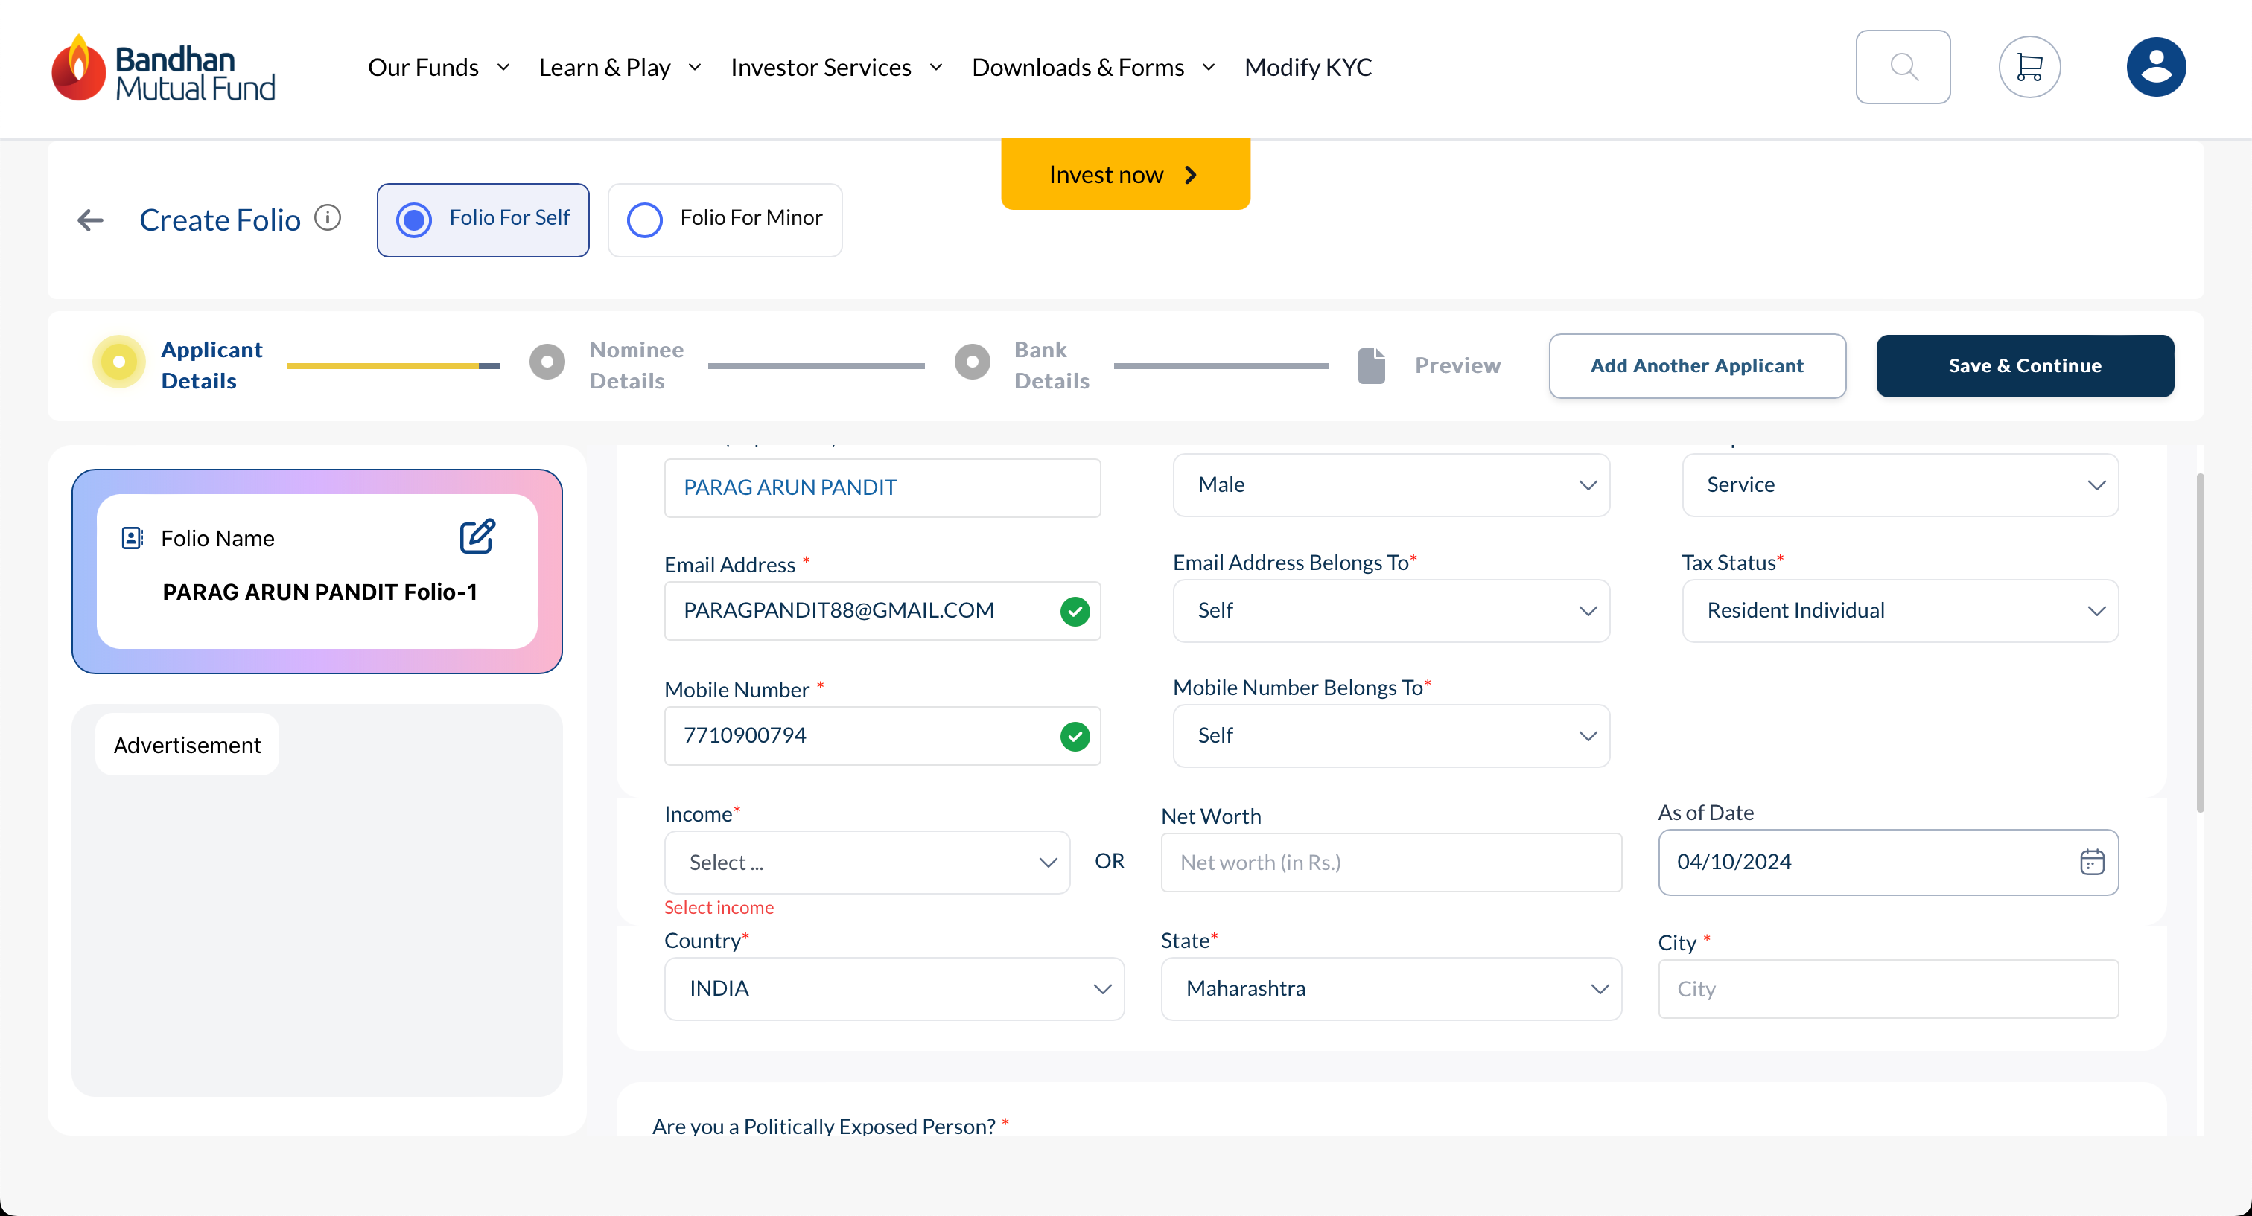

* Greater loading time, Vocabulary is not right

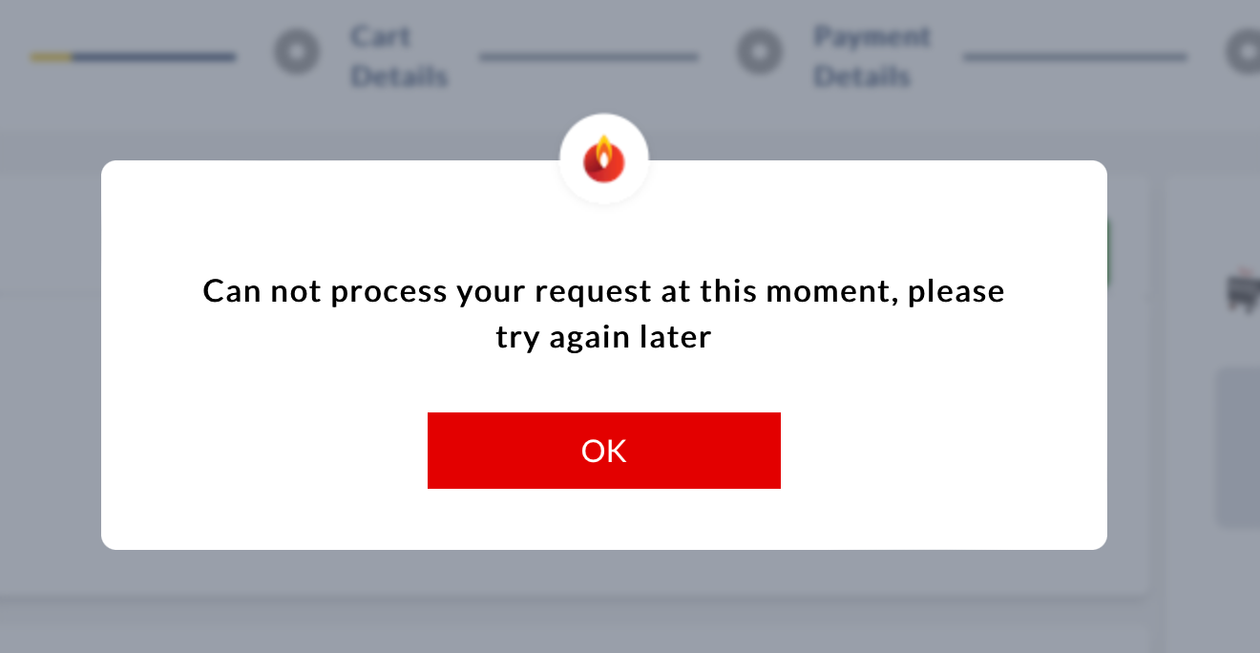

Folio detail colour should be similiar.

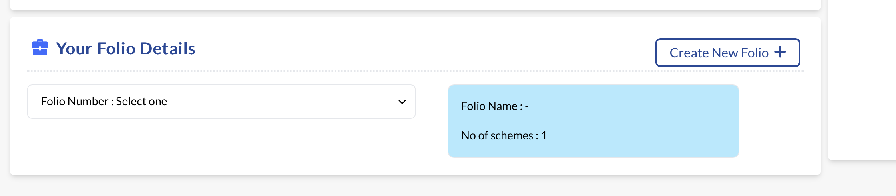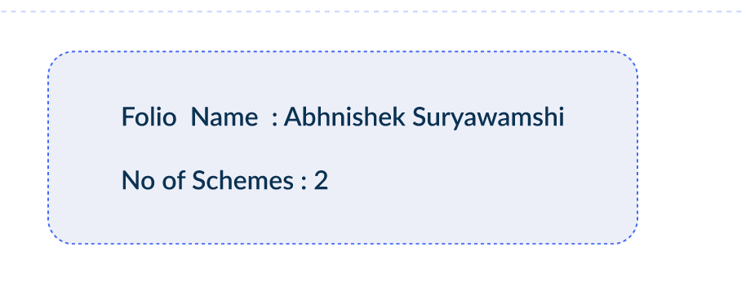

Check box statement is not aligned

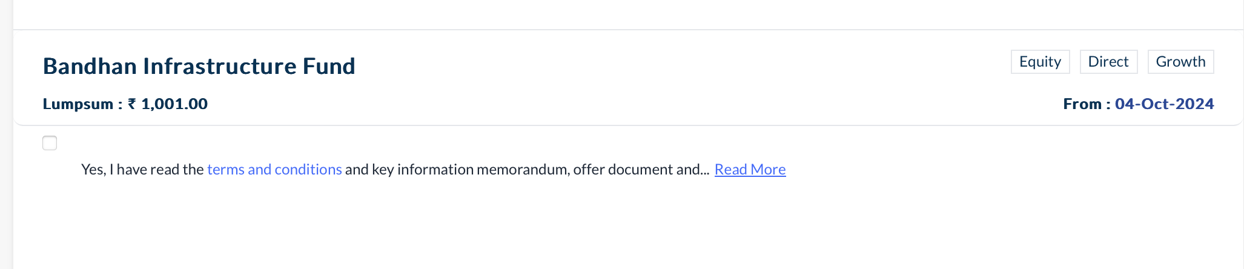

ISIP

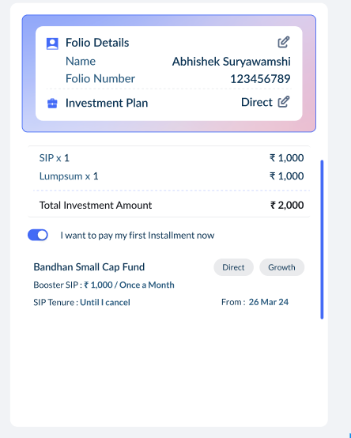

Month and year is coming two time.

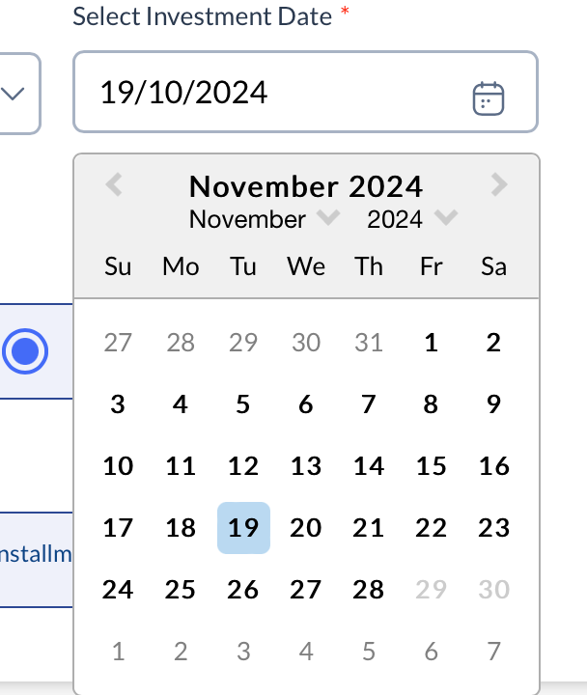

UI should be constant wherever there is investment mode.

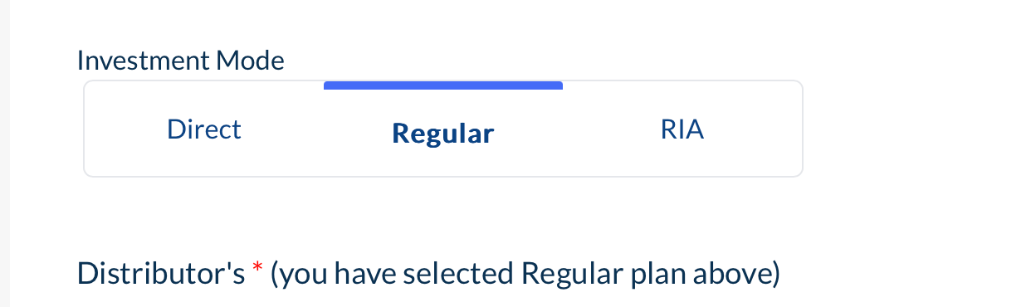

* Carousel dot shold be small

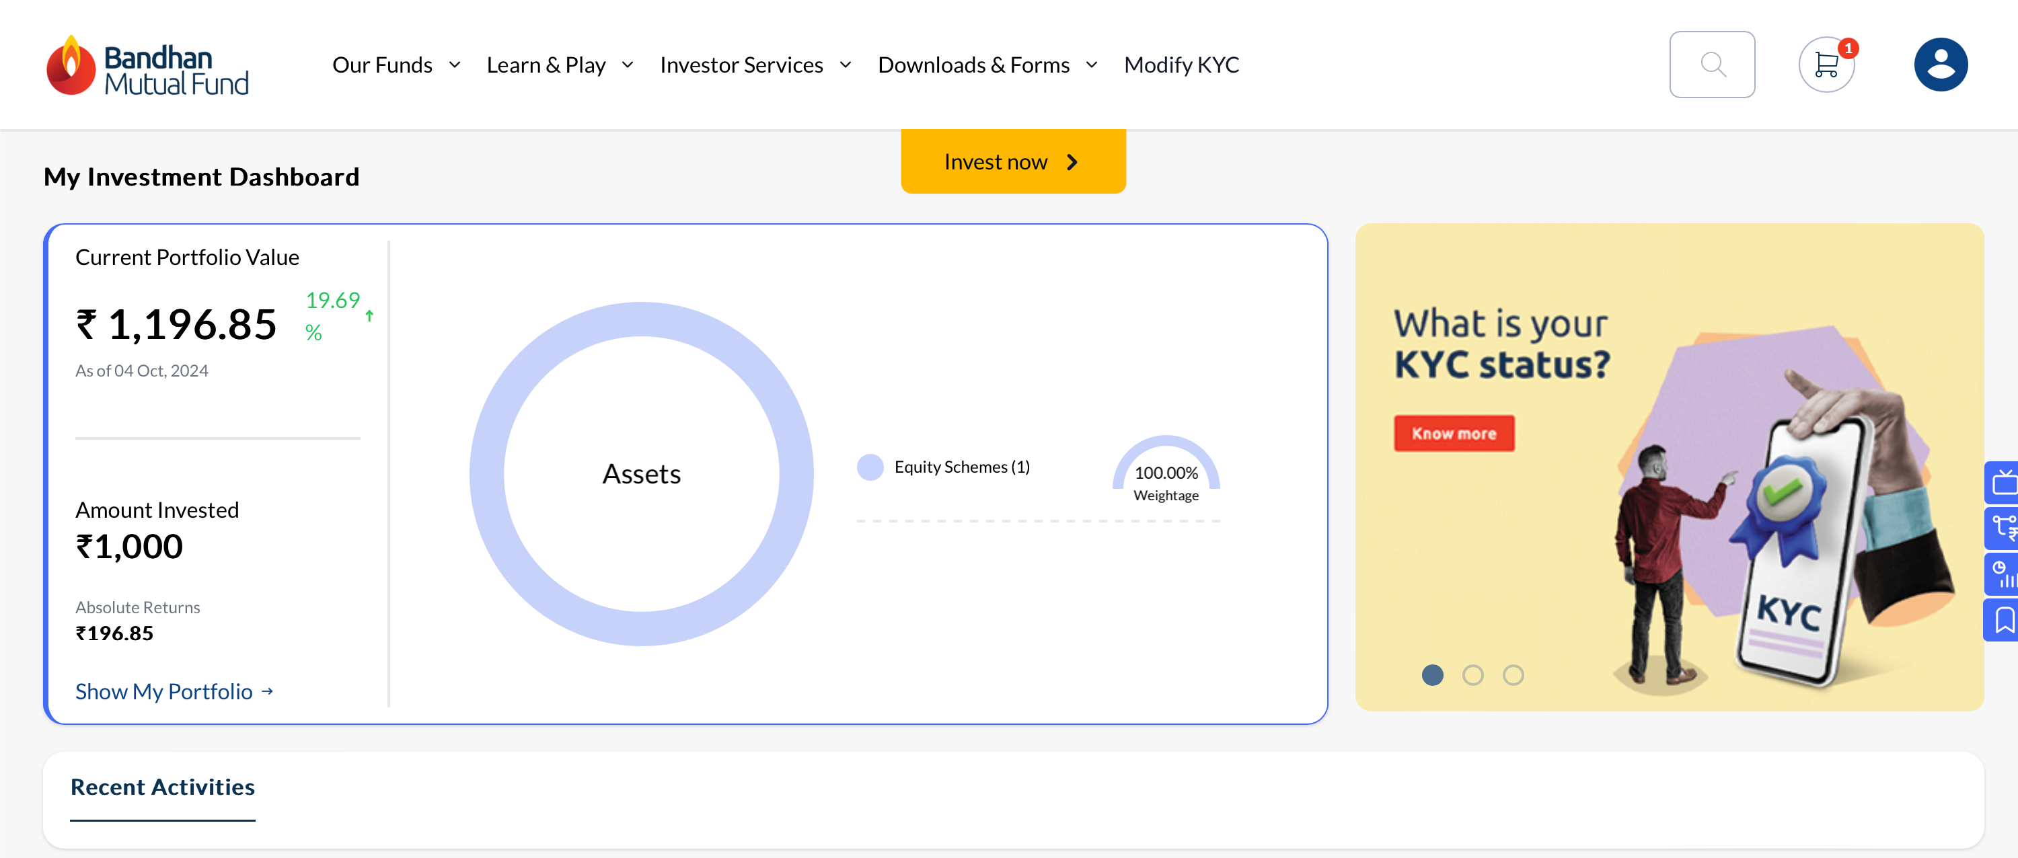

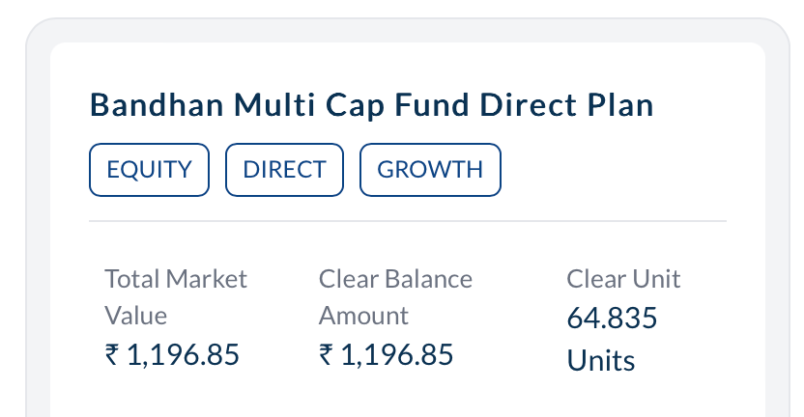

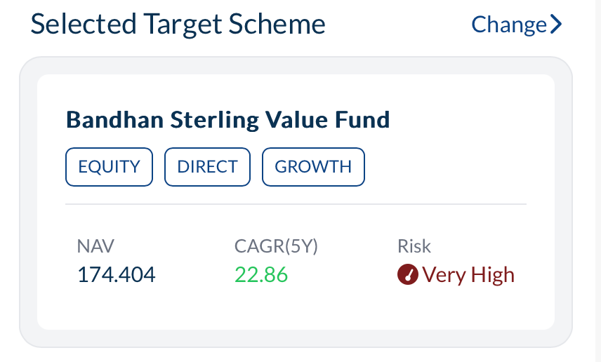

Payout and reinvest only first word should be capital

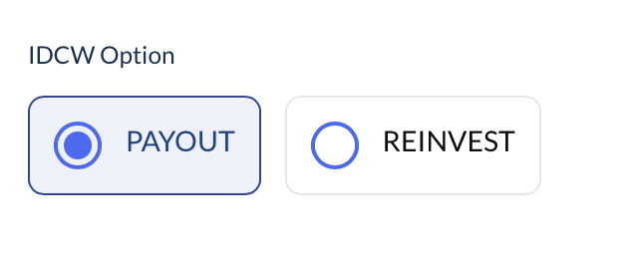

-Need to proper alignment

-risk icon

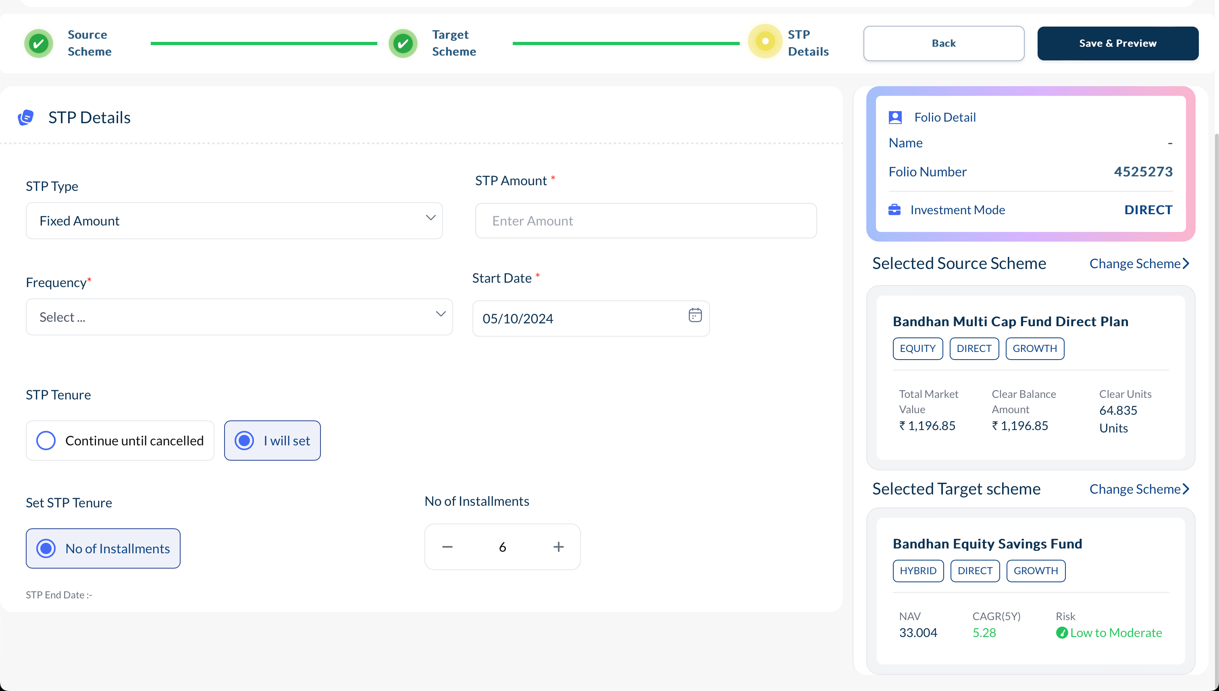

-Remove space between Fortnightly and Daily

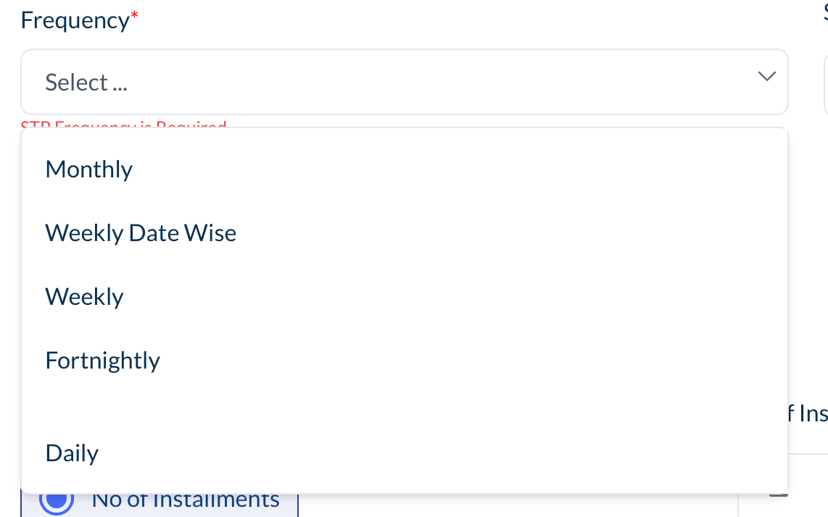

* Align botton

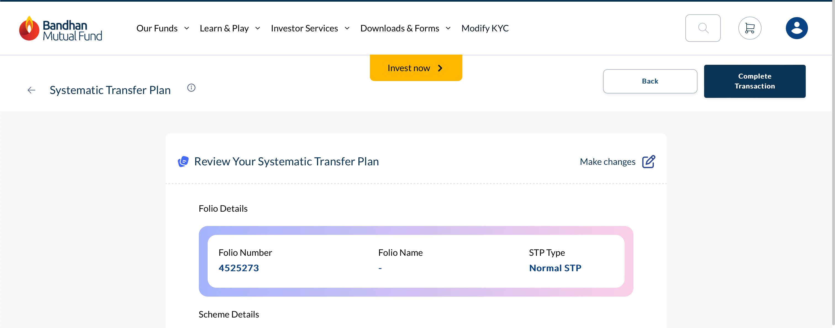

* Align Details properly

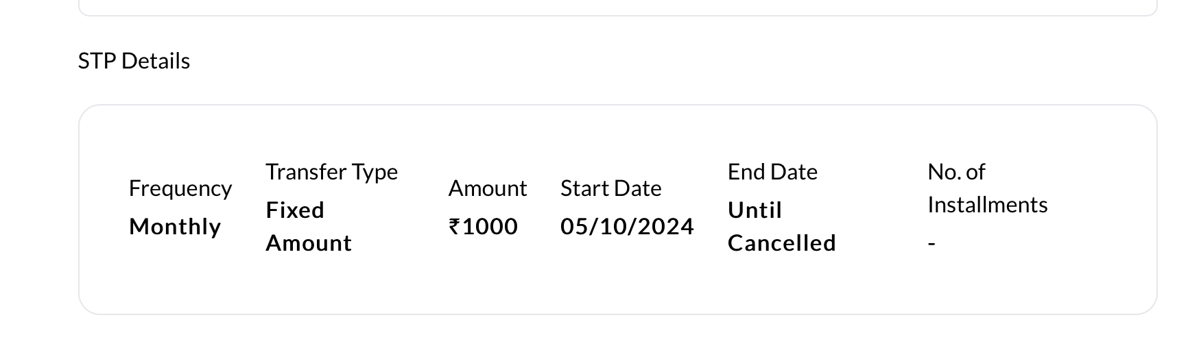

* Border radius of chips is not constant
* Select scheme for redemption should come in one line

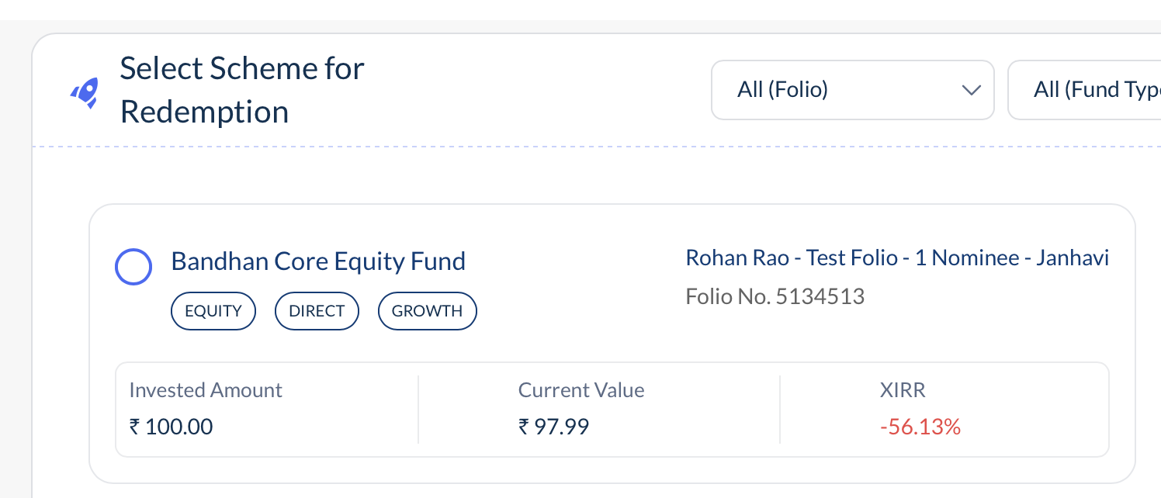

Alignment issue



Selected tab is not coloured



Switch and redeem is in capital and font size hierarchy is not proper

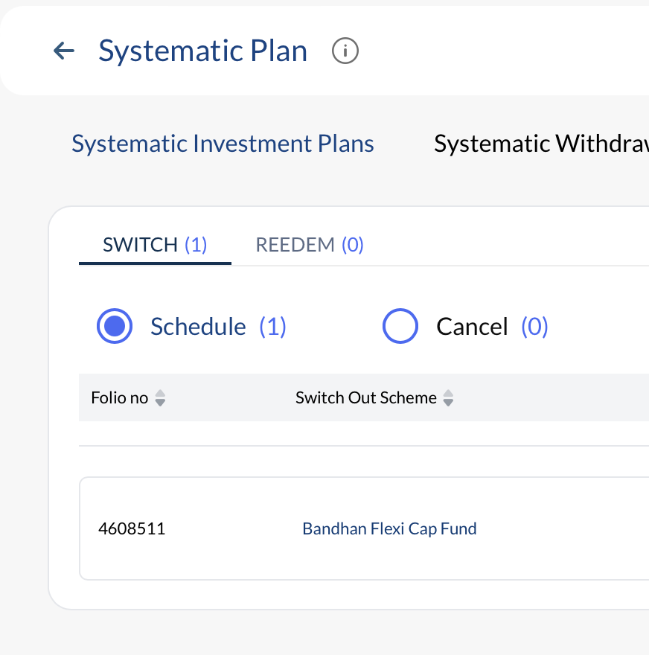



* Remove icon

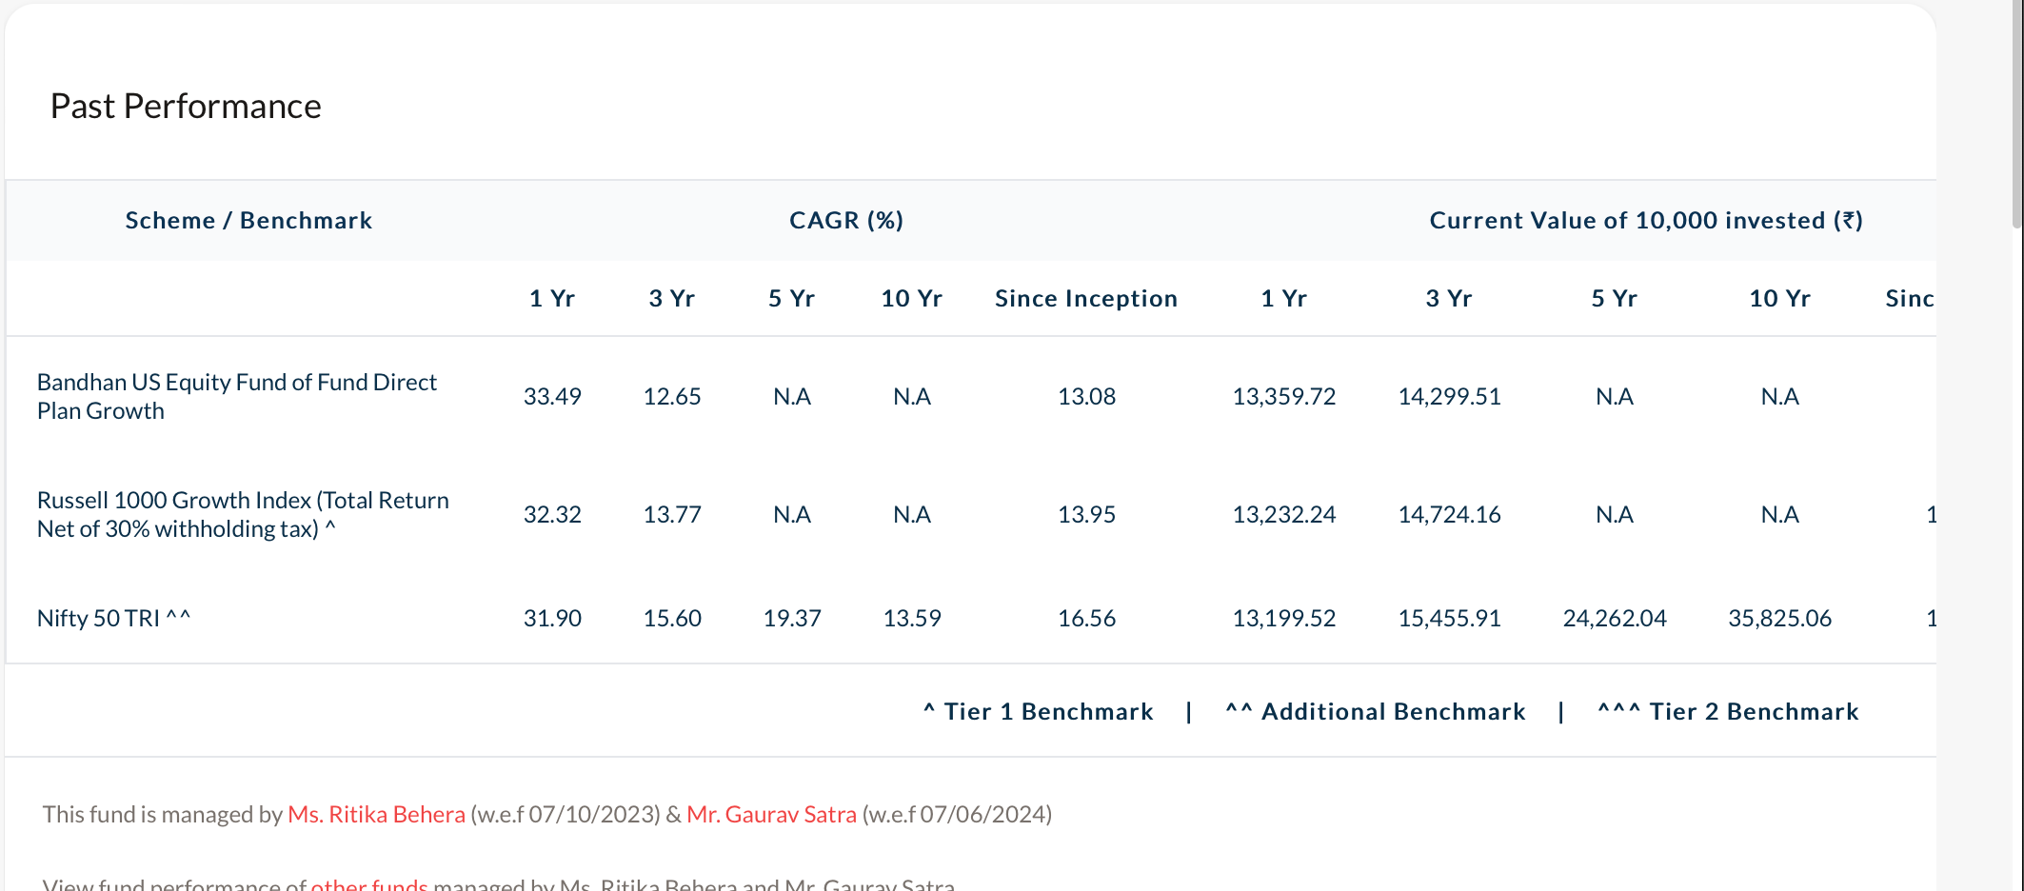

* Both are Container have same nomenclature (Past performance)

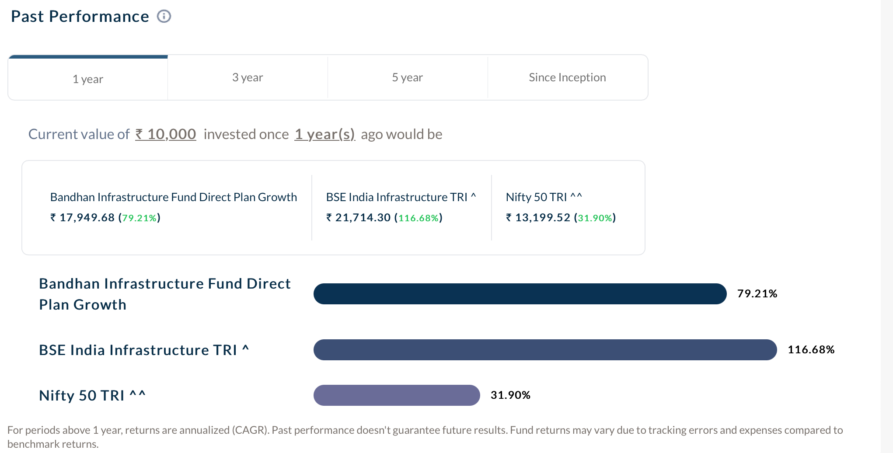

* In tab text alignment not proper

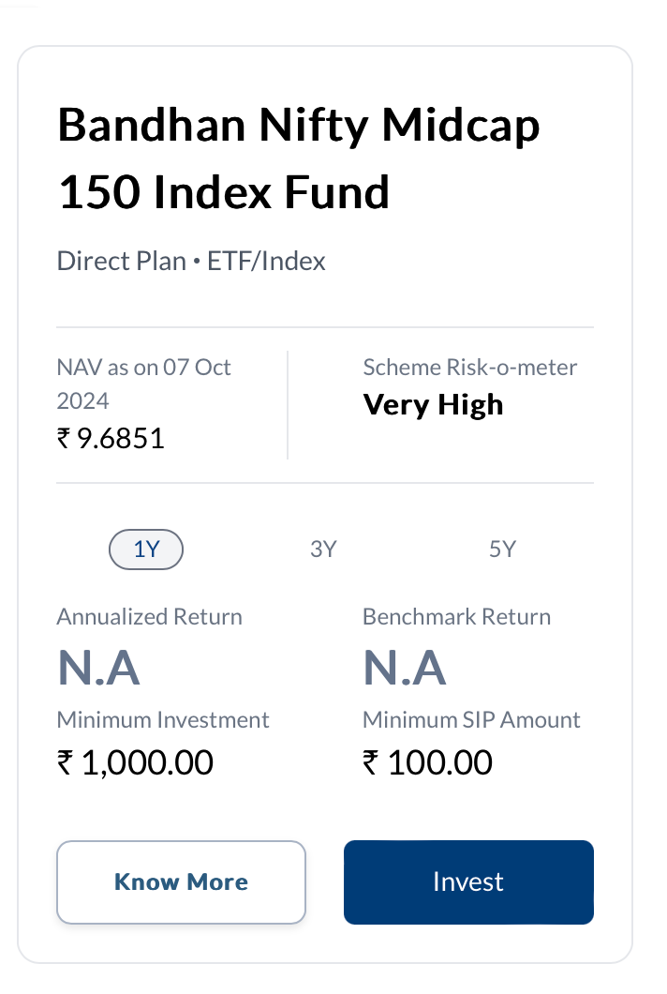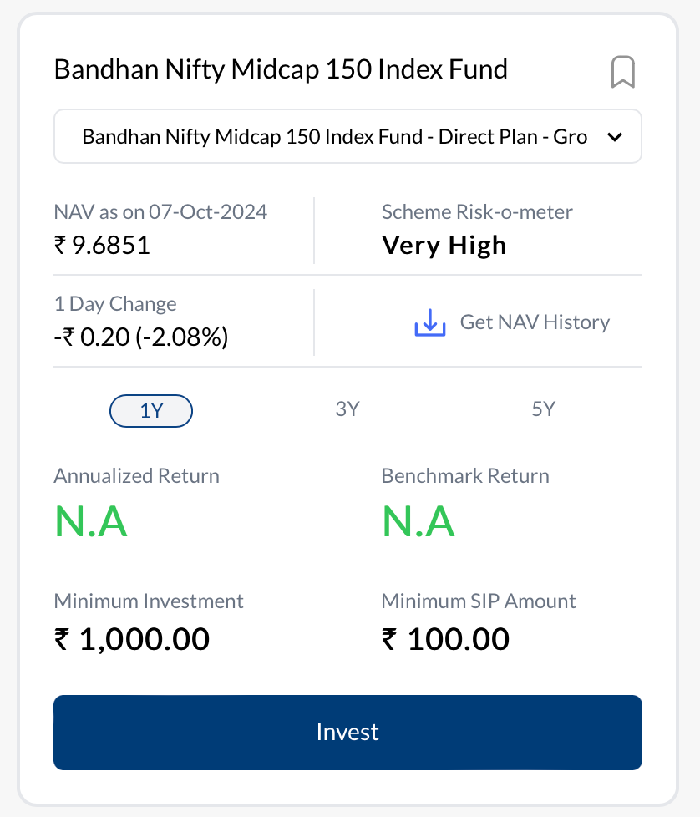

* Font weight of scheme name should be same, color of annualized return and benchmark return should be same

Transaction terms and condition should be similiar like this

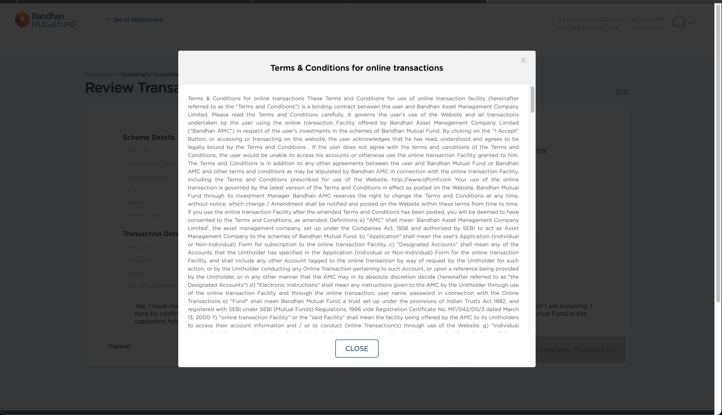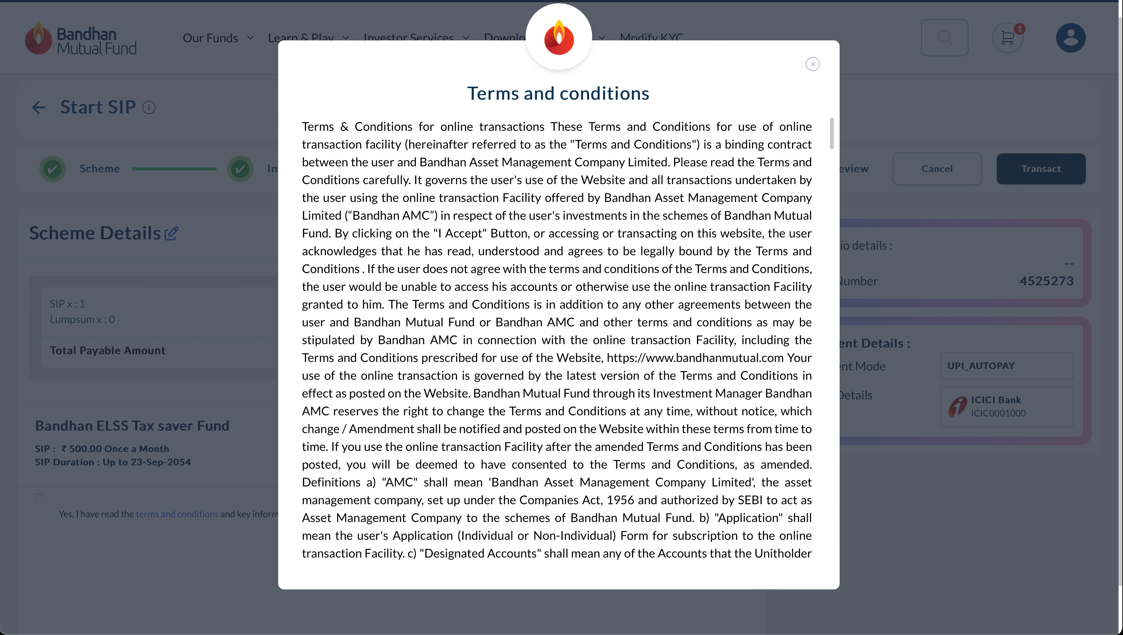

Term and condition text should be same like the existing bandhan portal.

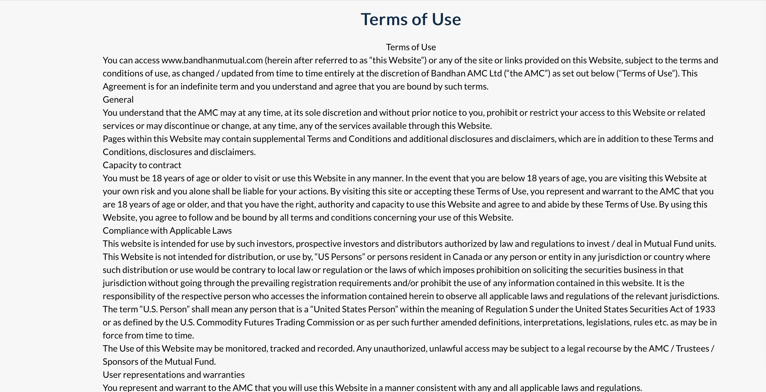

Tooltip size in irregular

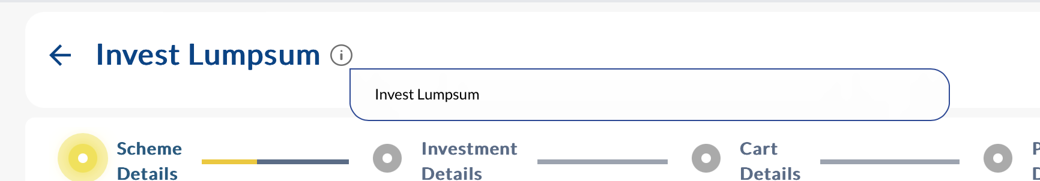

\

Preview page of SIP and SWP is different

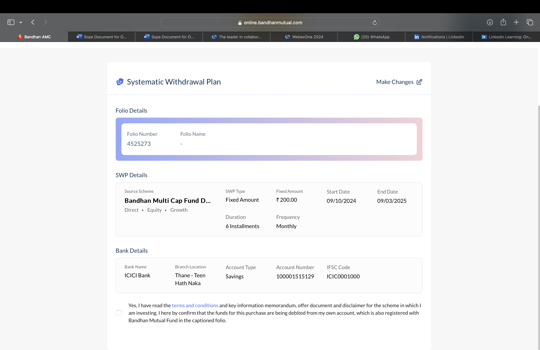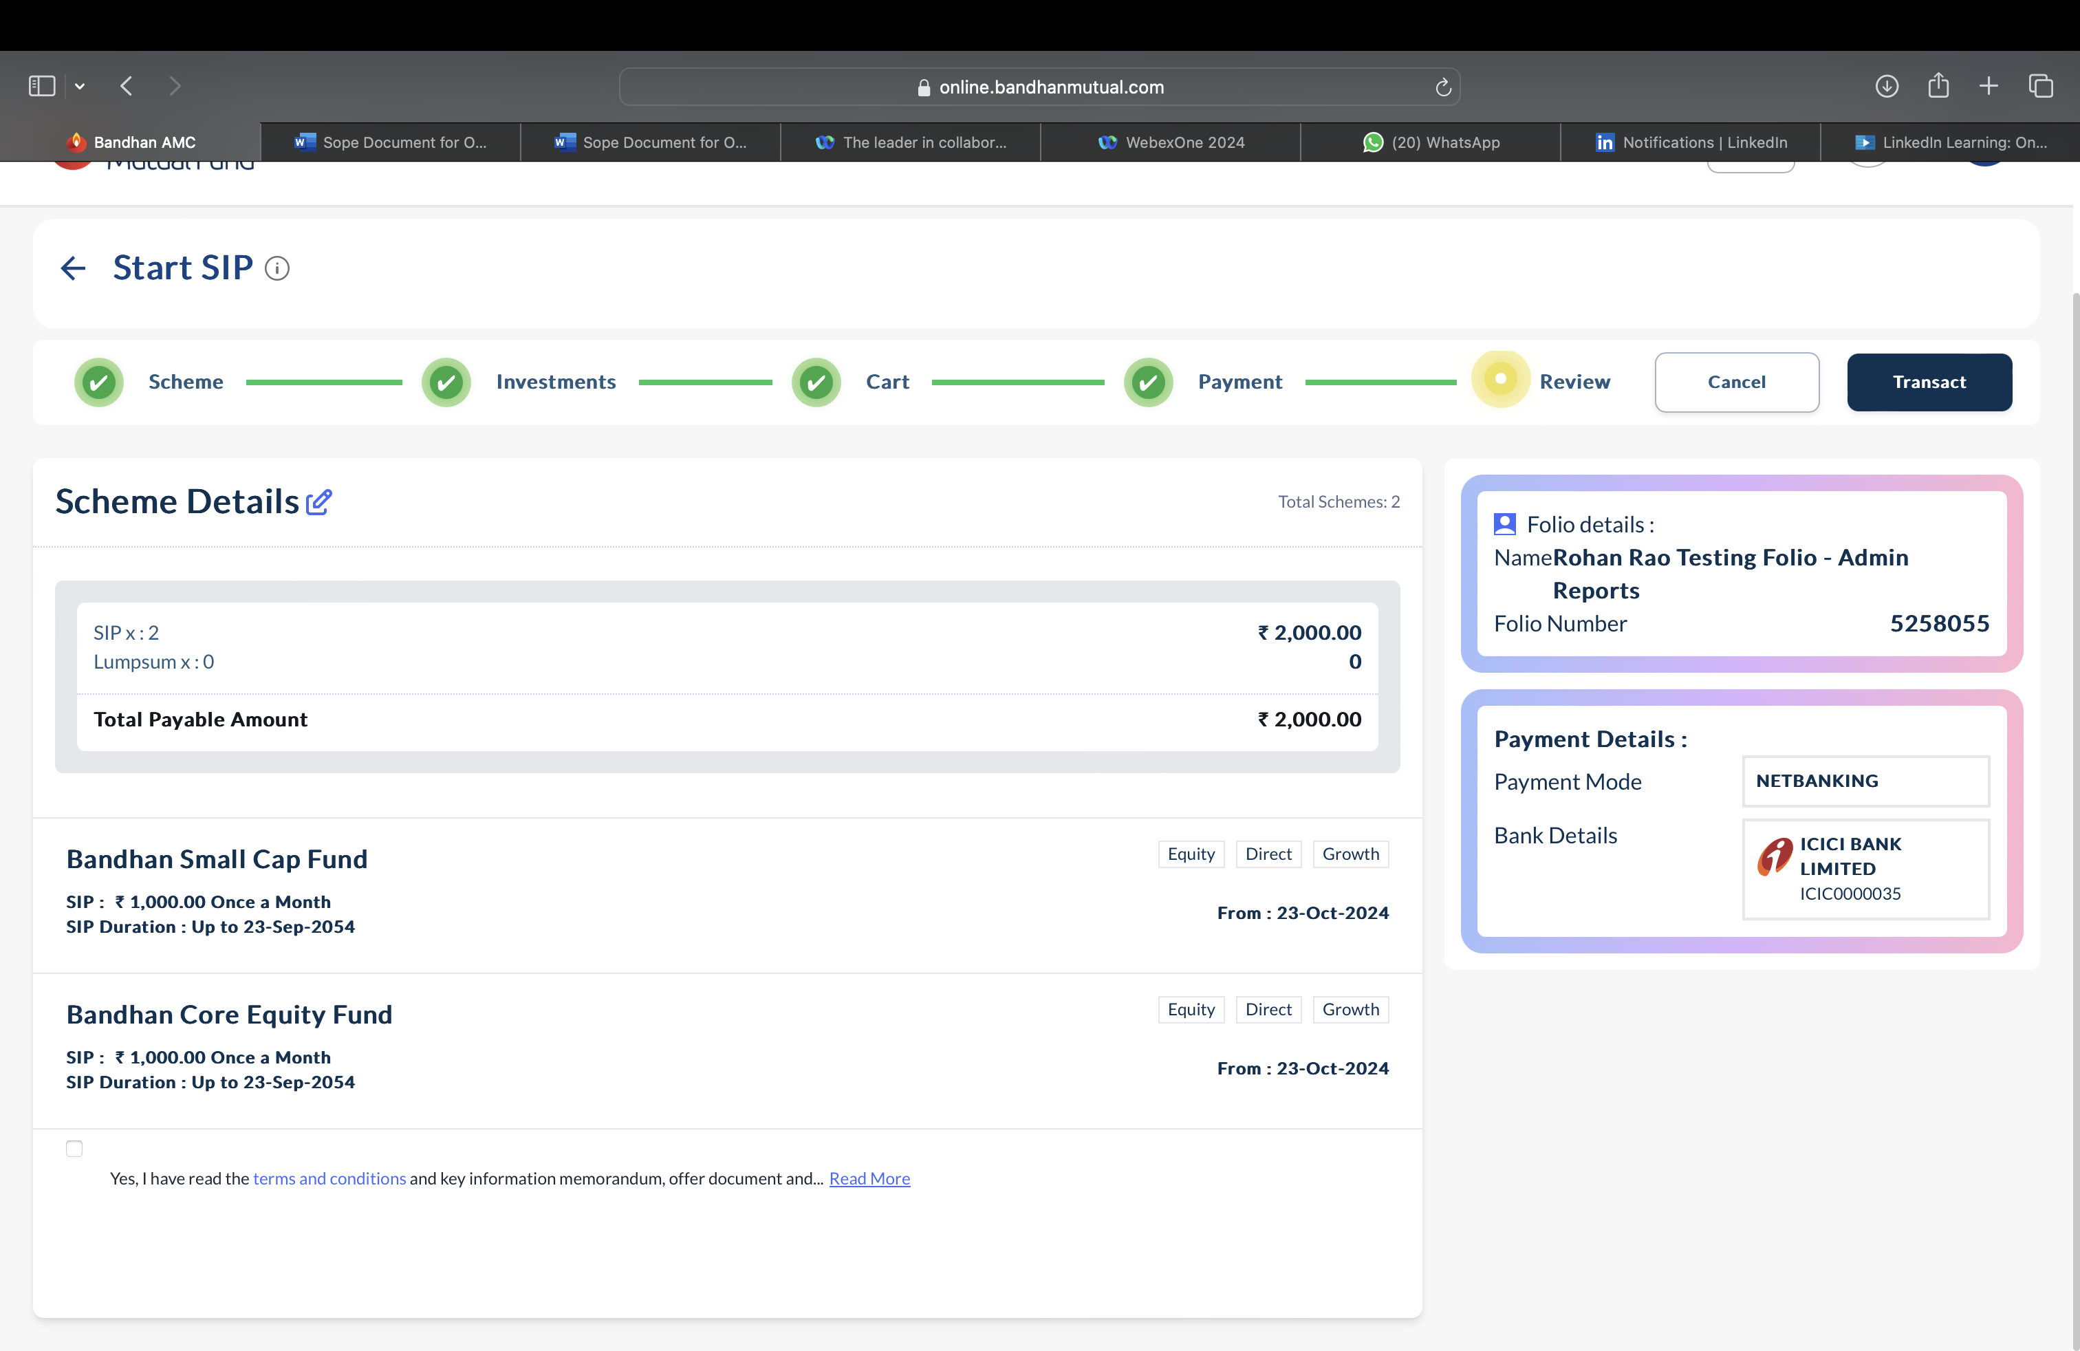

Color of remove folio button is not correct

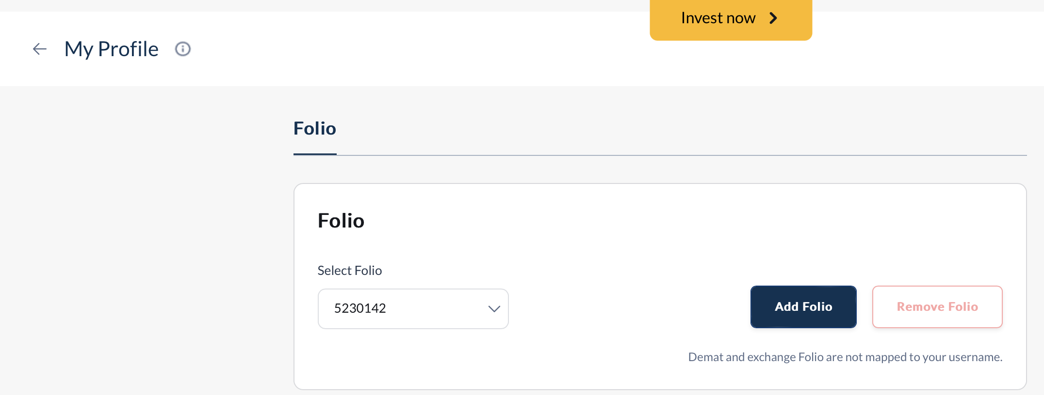

Increase the width of text box of name in one line

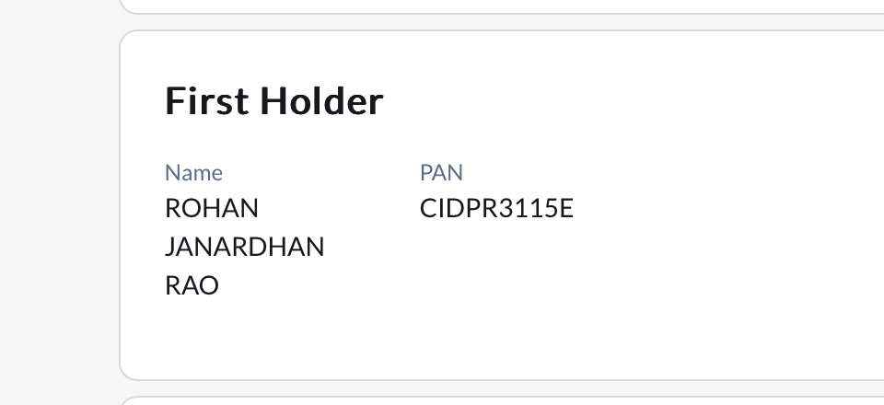

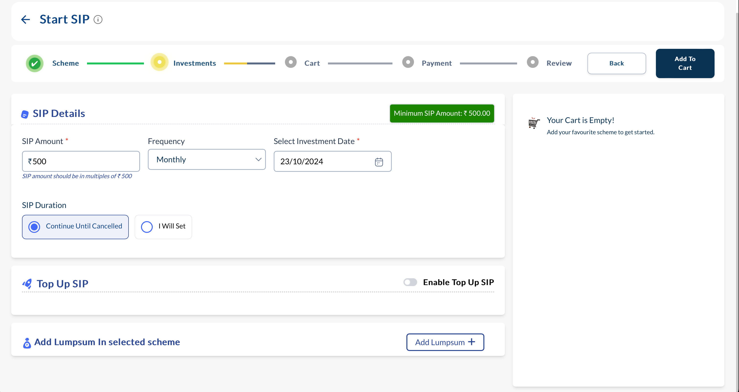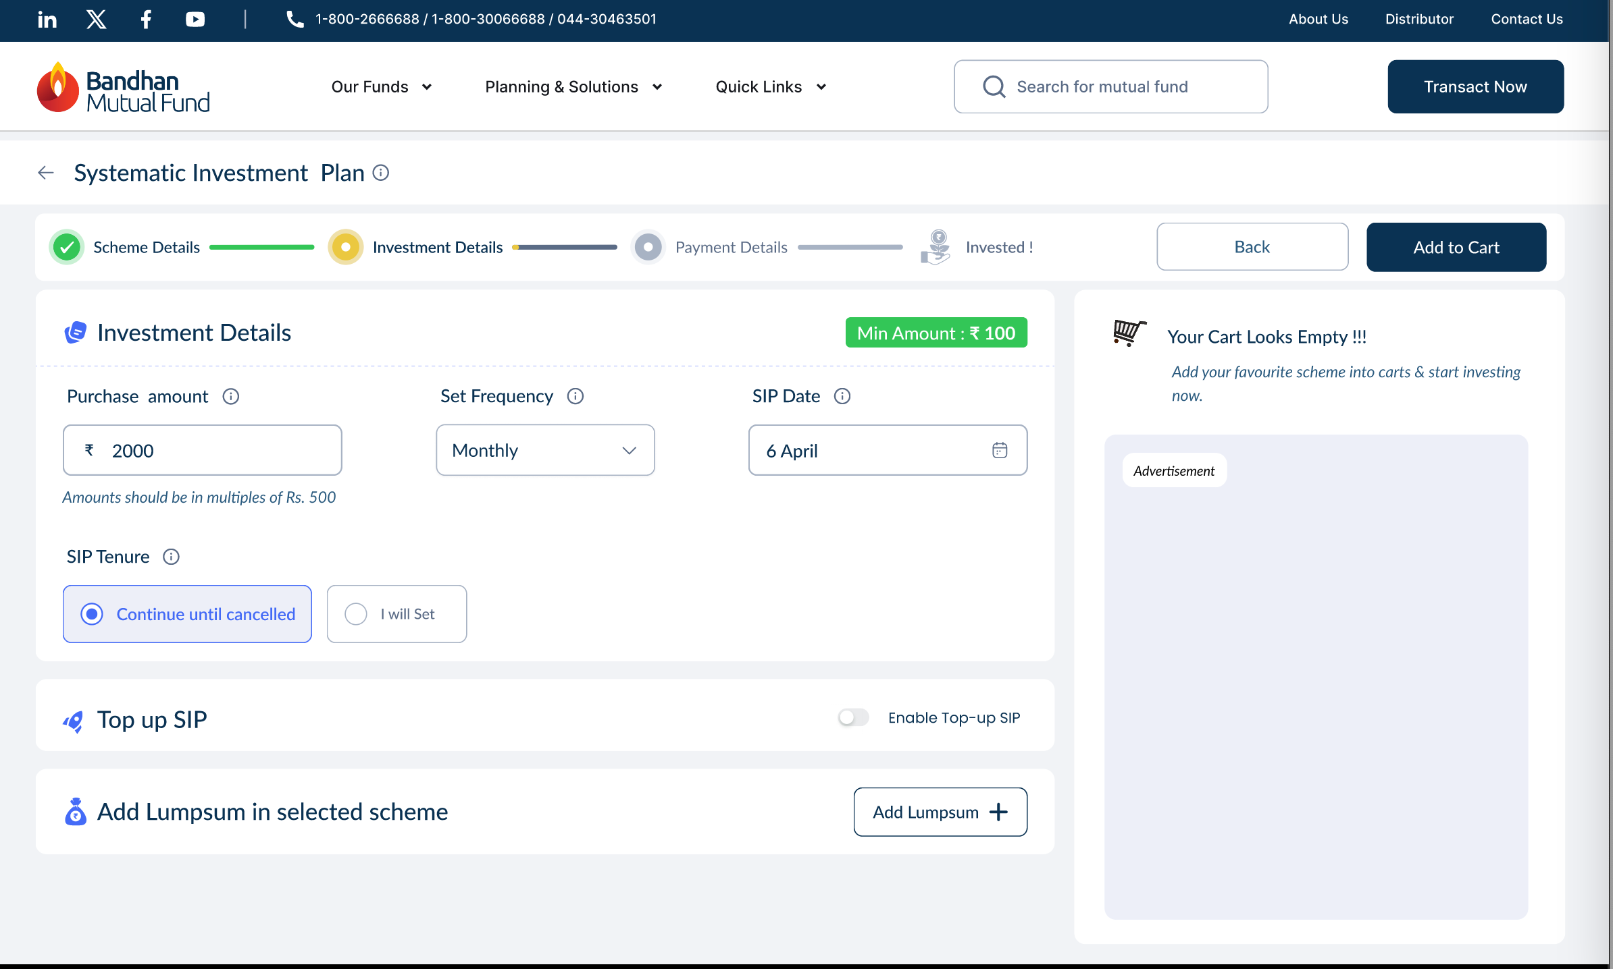

* Align properly



* Reduced tooltip box width

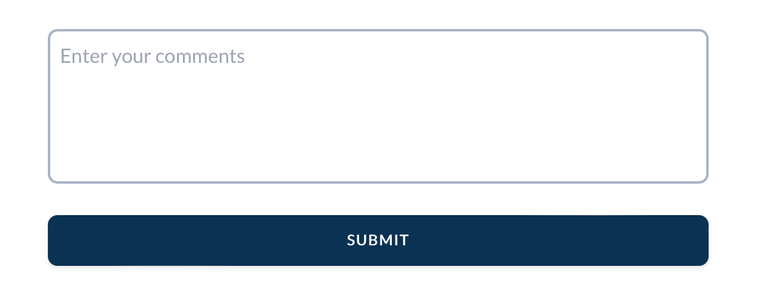

* CTA text is Bold

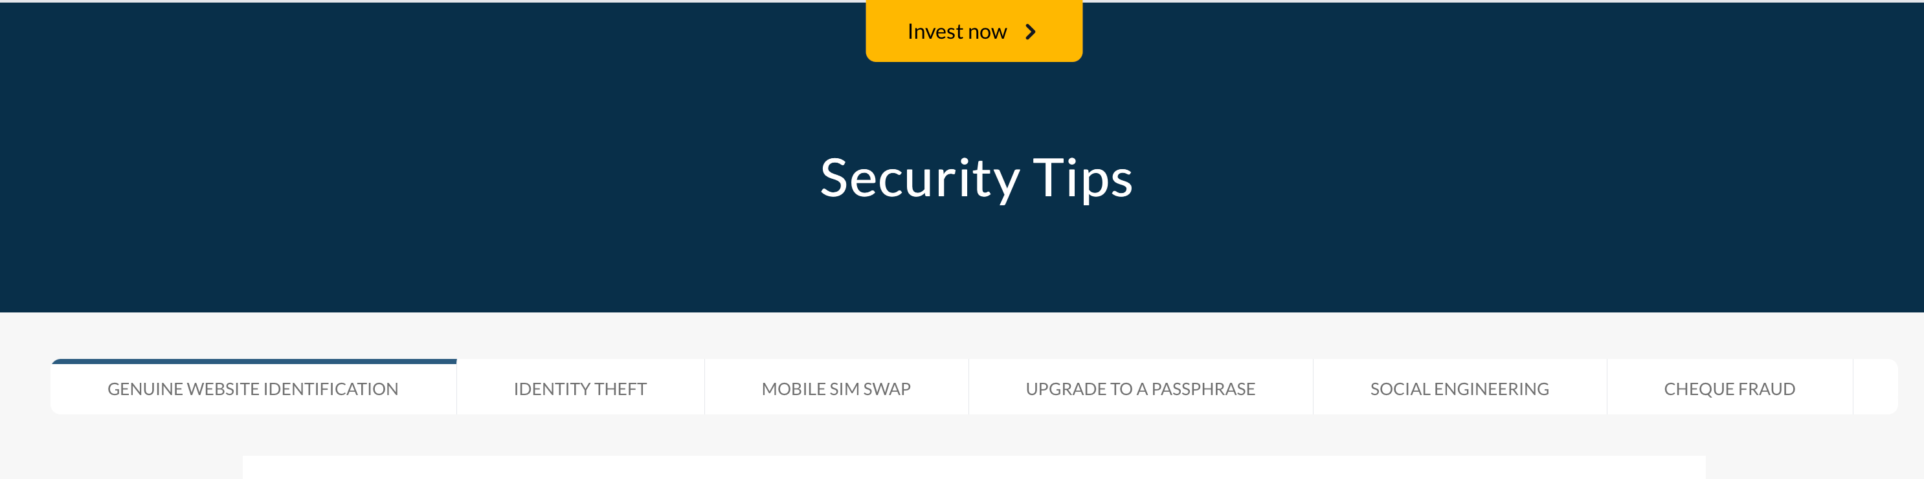

* In tab Text is bold